District Heating Thermodynamics and Hydraulics: Extended Technical Companion
Formula Derivations and Worked Numerical Examples — Part 2, Companion to the Union Centrale Compiled Dossier (Rev. 3-C)

DH Thermodynamics & Hydraulics — Technical Companion (Part 2)
Author / Content Owner: François Dorléans
AI transparency: this document was compiled and typeset with AI assistance (Claude, Anthropic). It is a deliberately narrow companion to the Union Centrale compiled dossier “District Heating Networks, 5GDHC & UTES” (Document ID UC-DHC-UTES-EN-2026, Revision 3-C, hereafter “Part 1”). Part 1 already contains a full, source-referenced treatment of district-heating history, the four-plus-one generation framework, network topology, and UTES; that material is not repeated here. This document exists only to go deeper on one thing Part 1 states but does not derive: the governing thermodynamic and hydraulic equations. All formulas are standard textbook relations; worked numerical examples use explicitly stated illustrative assumptions, not measured project data, and are labelled as such throughout.

Document ID: UC-DHC-THERMO-EN-2026
Revision: 2-C
Version date: 05/09/2026 (Rev. 2-C)
Companion to: UC-DHC-UTES-EN-2026, Rev. 3-C (“Part 1”)
Keywords: district heating, thermodynamics, hydraulics, heat transport, distribution losses, COP, exergy, Darcy-Weisbach, worked examples, meshing, Union Centrale

Revision History
Revision 1-C — First edition. Created by pruning the original source dossier “History of Urban District Heating Networks & 5GDHC” (Generic Technical Dossier, August 2026 update) down to the material not already covered in sufficient depth by Part 1 (UC-DHC-UTES-EN-2026, Rev. 3-C). Removed: historical origins, the four-generation classification, the 5GDHC definition, network-topology discussion, and global-status summary — all reproduced near-verbatim, with additional cross-referencing, in Part 1 §1.1–§1.4 and §1.6. Retained and substantially expanded: the governing thermodynamic and hydraulic equations (Part 1 §1.5 states these formulas in one paragraph each without derivation). This edition adds step-by-step derivations, physical interpretation, and three fully worked numerical examples — distribution heat loss by generation, heat-pump COP, exergy destruction, and hydraulic pressure drop with and without meshing — none of which appear in Part 1 or in the original source dossier.
Revision 2-C — Typesetting correction. Revision 1-C rendered every formula as inline Unicode-approximated text (e.g. ‘Q̇ = ṁ·cₚ·ΔT’ set in body-text font), which read as prose rather than mathematics. All governing equations and worked-example calculation steps — 23 in total — are now typeset as proper display equations (Computer Modern math font: correct fractions, subscripts, Greek letters, radicals) and centred on the page, matching standard engineering and physics publication conventions. No content, derivation, or numerical result changed from Revision 1-C; only the typesetting of the mathematics.
Source lineage: District_Heating_Networks_History_5GDHC_Dossier_Updated (Generic Technical Dossier, August 2026 update), authored by François Dorléans, retained here only as the origin of §6 (Thermodynamic Foundations and Governing Equations), which this document extends. All other sections of that source dossier are superseded by Part 1 and are not reproduced.

0. Purpose, Scope and Relationship to Part 1
The Union Centrale programme now maintains a compiled reference document — “District Heating Networks, Fifth-Generation Heating & Cooling (5GDHC), and Underground Thermal Energy Storage (UTES)”, Document ID UC-DHC-UTES-EN-2026, Revision 3-C (“Part 1”) — that already incorporates, near-verbatim, the historical, classificatory, and topological content of the original standalone dossier “History of Urban District Heating Networks & 5GDHC” (August 2026 update). Maintaining two documents that say the same thing about the same subject in the same words serves no one: it doubles the maintenance burden and gives a reader no signal about which version is authoritative.
This document therefore keeps only what Part 1 does not already cover in adequate depth. Table 0.1 makes that boundary explicit, section by section, so a reader can move between the two documents without guessing where to look.
Topic (original source dossier) | Status | Where to read it
Historical origins and early developments | Fully covered, near-verbatim | Part 1, §1.1
The four generations of district heating (1GDH–4GDH) | Fully covered, near-verbatim | Part 1, §1.2
Fifth-generation district heating and cooling (5GDHC) | Fully covered, near-verbatim, plus an addition (4GDH/5GDHC complementarity) that the original source dossier lacks | Part 1, §1.3 and §1.3.1
Network topologies and the importance of meshing | Fully covered, near-verbatim | Part 1, §1.4
Thermodynamic foundations and governing equations | Equations stated, not derived; no worked examples | Part 1, §1.5 (summary) — this document, §1–§5 (full treatment)
Global status, benefits and challenges | Fully covered, near-verbatim | Part 1, §1.6
References and acronyms | Superset already in Part 1 Annex A/B | Part 1, Annex A.1 and Annex B

Everything from here on is therefore new material: derivations of the five governing relations Part 1 §1.5 states, and worked numerical examples that quantify — rather than merely assert — the claims made qualitatively in Part 1 (for instance, that 5GDHC distribution losses fall “often by 75% or more” relative to 1GDH, or that meshing “lowers average pressure drop”). Readers who only need the headline formulas and their role in the wider Union Centrale argument should read Part 1 §1.5 and stop there; this document is for readers who want to reproduce or extend the numbers.

1. Heat Transport and Energy Balance

1.1 Derivation
A fluid stream carries thermal power in proportion to its mass flow rate and the temperature drop it undergoes between two points. For an incompressible fluid with negligible kinetic and potential energy change, the steady-flow energy balance over a control volume reduces to:
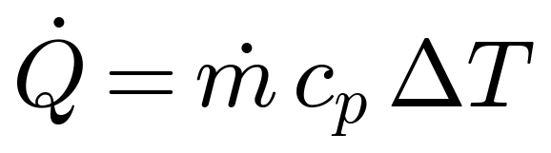
where ṁ is the mass flow rate (kg/s), cₚ is the specific heat capacity at constant pressure (J/kg·K, ≈ 4,180 J/kg·K for water near 50–80 °C), and ΔT is the temperature difference between supply and return (K). This is simply the first law of thermodynamics applied to a pipe: the enthalpy the fluid loses (or gains) as it flows from supply to return equals the heat delivered (or absorbed) along the way, since no work is done and elevation change is negligible.
Rearranged for design purposes, the mass flow required to deliver a given power is:
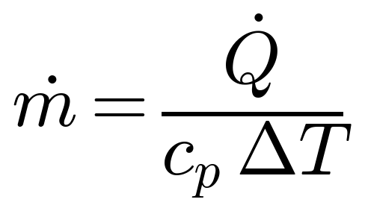
This single relation is the origin of the central hydraulic trade-off in every generation of district heating: for a fixed delivered power, halving ΔT doubles the required mass flow. Since pipe pumping power scales with roughly the cube of flow velocity (§5 below), this is not a minor detail — it is the reason 5GDHC networks, which operate at ΔT as low as 5–10 K rather than the 20–30 K typical of 3GDH/4GDH, cannot simply reuse 3GDH pipe sizing rules.

1.2 Worked example
A substation must deliver 1 MW of heat. At a 3GDH ΔT of 30 K (e.g. 80 °C supply, 50 °C return), and at a 5GDHC ΔT of 5 K (e.g. 20 °C supply, 15 °C return):
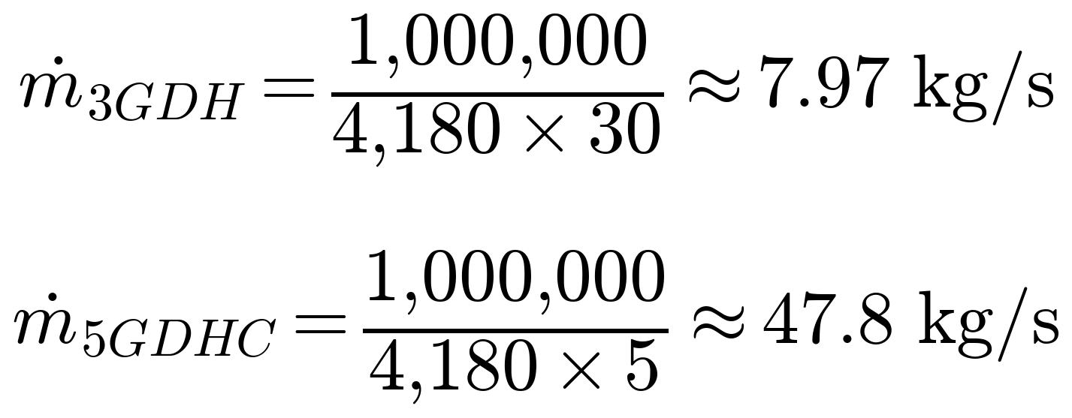
The 5GDHC case requires six times the mass flow for the same delivered power. Section 5 carries this same pair of numbers through the hydraulic-loss calculation to show what it costs in pumping energy, and why meshing is the structural answer rather than an optional refinement.

2. Distribution Heat Losses

2.1 Derivation
Heat escaping a buried, insulated pipe travels by conduction through the insulation and, beyond it, through the soil to the undisturbed far-field ground temperature. For a single cylindrical insulation layer, steady-state radial conduction gives a loss per unit pipe length of:
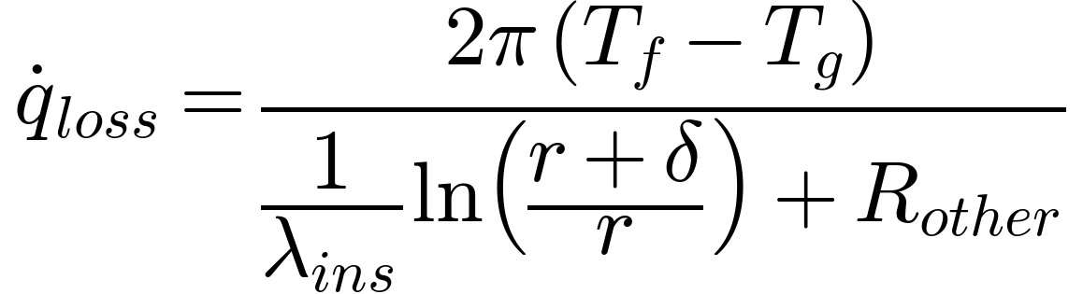
where T_f is the fluid temperature, T_g is the ground temperature, λ_ins is the insulation's thermal conductivity (W/m·K), r is the pipe's outer radius, δ is the insulation thickness, and R_other lumps together any additional thermal resistance (soil, pipe wall, internal film coefficient) not explicitly modelled. The (1/λ_ins)·ln((r+δ)/r) term is the standard cylindrical-wall conduction resistance per unit length; it is exactly analogous to the planar conduction resistance L/λ·A, but accounts for the fact that a cylindrical shell's cross-sectional area for conduction grows with radius.
More generally, once the resistances of every layer (pipe wall, insulation, soil) are summed into an overall resistance R_total, the loss can be written as follows, with U the overall heat-transfer coefficient:

Because insulation dominates R_total in a well-built pre-insulated pipe (soil and pipe-wall resistance are typically small by comparison), the practical design lever is δ and λ_ins — and, for network operators rather than pipe manufacturers, T_f: the lower the operating temperature, the smaller ΔT = T_f − T_g and the smaller the loss, for an identical pipe.
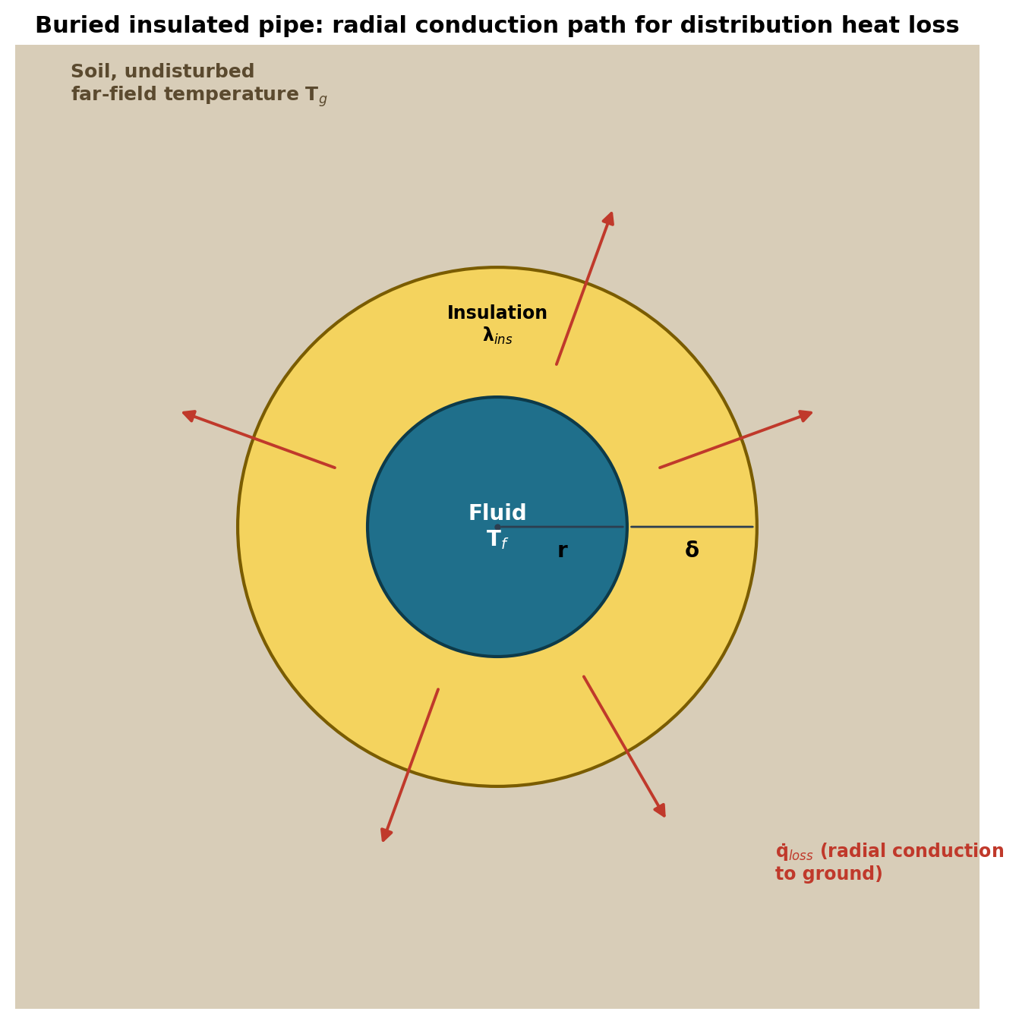
Figure 1. Radial conduction path for a buried insulated pipe: fluid at T_f, insulation of thickness δ and conductivity λ_ins around a pipe of outer radius r, losing heat to soil at far-field temperature T_g. Source: author’s schematic, illustrating the q̇_loss formula in Part 1 §1.5 / this document §2.1.

2.2 Worked example: distribution loss by generation
Take a representative DN100 pre-insulated pipe (outer pipe radius r = 0.05 m) with 50 mm of polyurethane (PUR) foam insulation (δ = 0.05 m, λ_ins ≈ 0.027 W/m·K, a typical manufacturer value for aged PUR), a lumped additional resistance R_other = 0.10 m·K/W (illustrative, covering soil and pipe-wall effects), and a ground temperature T_g = 10 °C:
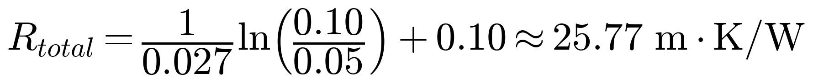
confirming that insulation, not soil, dominates in this configuration.
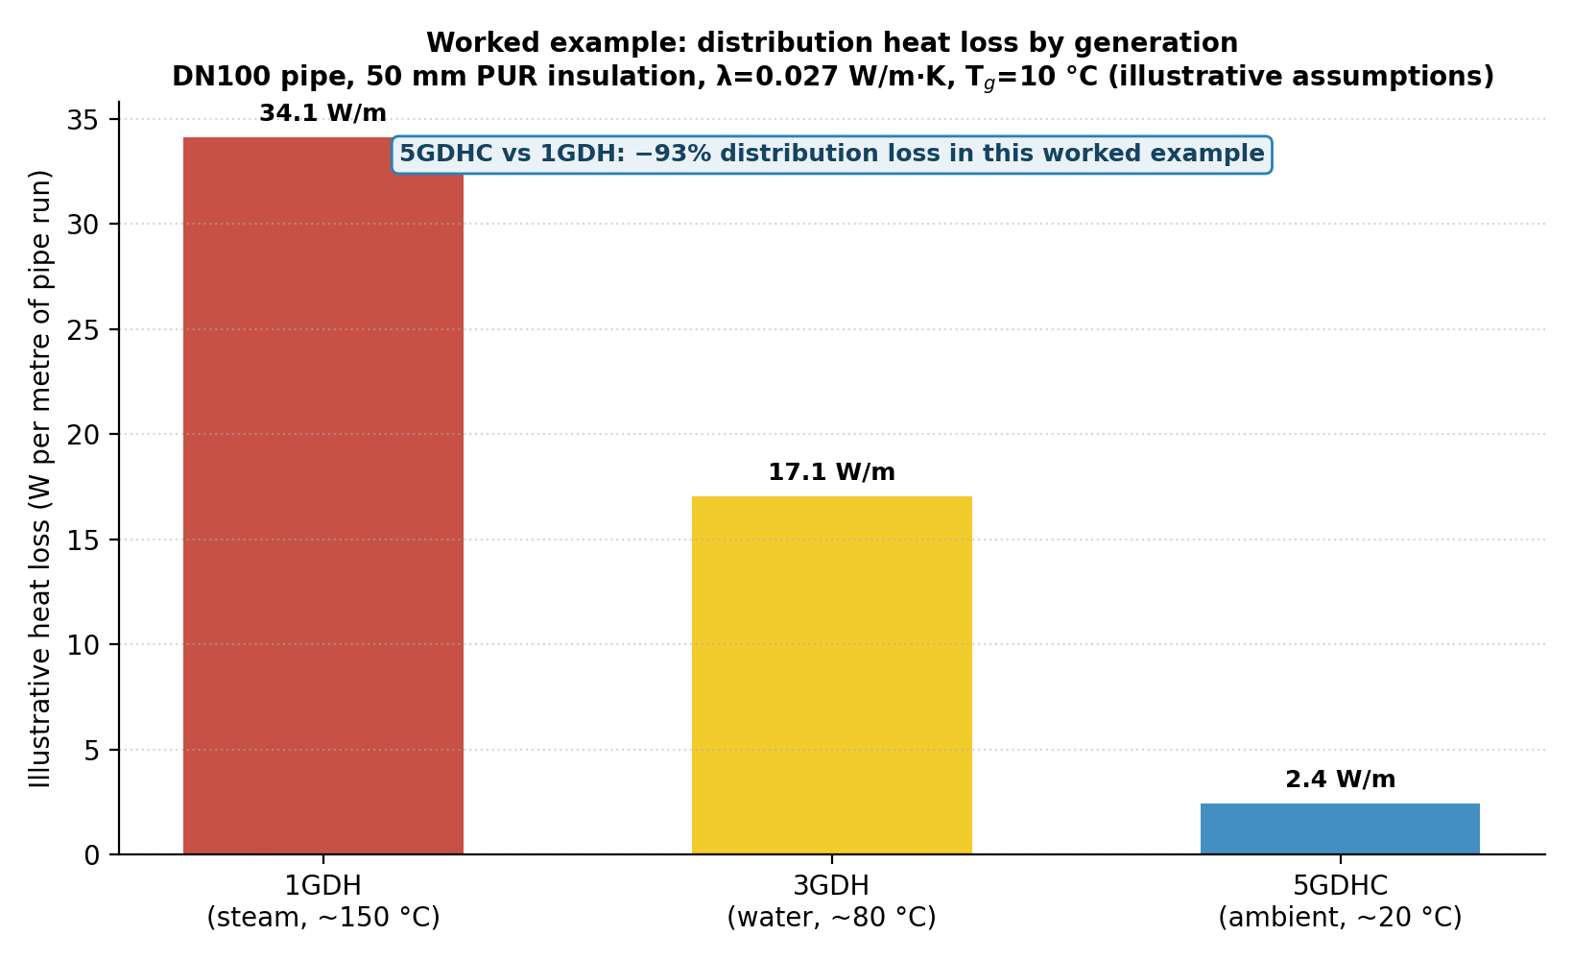
Figure 2. Worked, assumption-explicit comparison of distribution heat loss per metre of pipe run at representative supply temperatures for 1GDH (≈150 °C steam), 3GDH (≈80 °C water), and 5GDHC (≈20 °C ambient), using the pipe and insulation parameters in §2.2. This is an illustrative parametric example, not a measured or project-specific figure; it is presented to give the “often by 75% or more” reduction already stated qualitatively in Part 1 §1.5 an explicit, reproducible number.
Applying the general form at T_f = 150 °C, 80 °C and 20 °C:
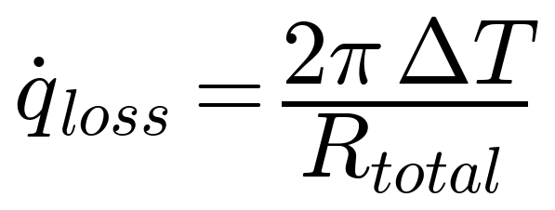
a 93% reduction from 1GDH to 5GDHC in this worked example, comfortably inside (and somewhat beyond) the “75% or more” range Part 1 states. The result is sensitive to the assumed insulation thickness and conductivity, which is exactly why it is presented here as a reproducible calculation with stated inputs rather than as a general statistic: a reader with project-specific pipe data can substitute their own r, δ, λ_ins and T_g directly into the same formula.

3. Heat-Pump Performance: Carnot and Real COP

3.1 Derivation
The Carnot cycle sets the theoretical efficiency ceiling for any heat pump operating between a cold reservoir at T_cold and a hot reservoir at T_hot (both in kelvin). For heating and cooling duty respectively:
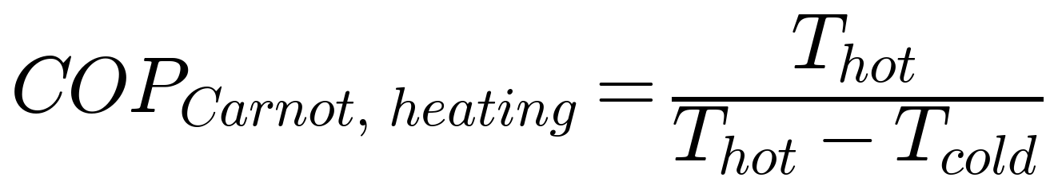
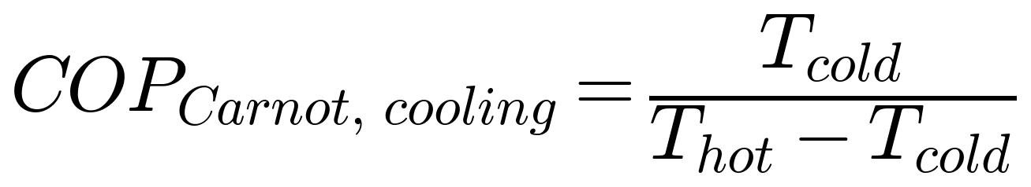
Both follow directly from applying the Carnot efficiency η_Carnot = 1 − T_cold/T_hot to a reversible heat pump: the heating COP is the reciprocal of that efficiency, since a heat pump delivers heat rather than work. The key structural feature, visible directly in the formula, is that COP_Carnot depends only on the lift T_hot − T_cold, not on the absolute temperatures themselves — a heat pump lifting from 15 °C to 45 °C (a 30 K lift) has the same Carnot ceiling as one lifting from 60 °C to 90 °C, even though the second pair of temperatures is much higher in absolute terms.
Real machines fall short of the Carnot ceiling because real compression and heat exchange are irreversible. This is captured with a second-law (Carnot) efficiency η_Carnot, typically 0.4–0.6 for well-designed commercial heat pumps:
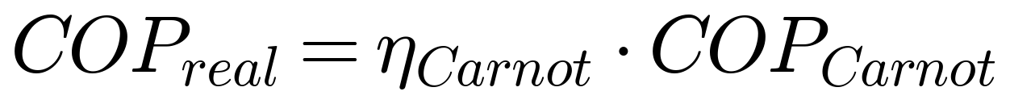
Electricity consumption for a given heating duty follows directly as:
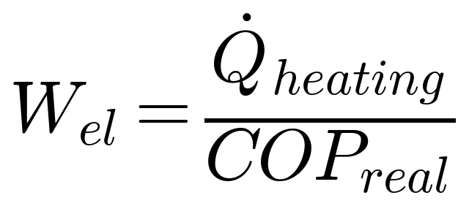
Section 2.5.4 of Part 1 builds on this same framework to show that η_Carnot itself is not fixed — it depends on the refrigerant used in the compression cycle, and that dependence flips direction around 100–120 °C delivery temperature. This document does not repeat that discussion; it only supplies the COP derivation Part 1 assumes.

3.2 Worked example
A 5GDHC building substation lifts from a 15 °C ambient loop to a 45 °C emitter (a 30 K lift, both temperatures converted to kelvin: 288.15 K and 318.15 K):
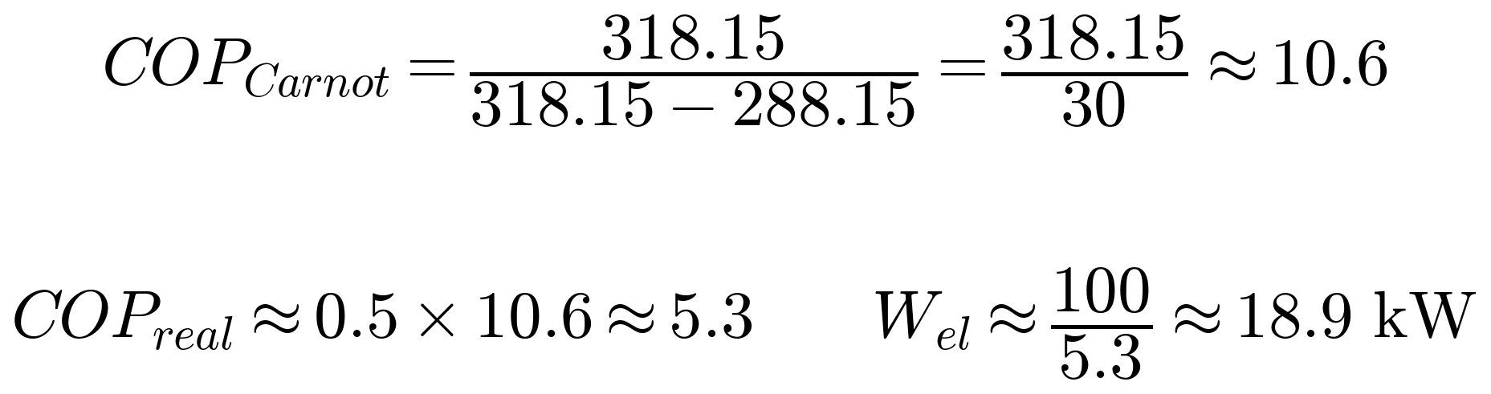
to deliver 100 kW of heat, the heat pump draws roughly 18.9 kW of electricity. By contrast, an air-source heat pump on a cold winter day drawing from −5 °C air to the same 45 °C emitter faces a 50 K lift:
roughly 40% more electricity for the same heat delivered. This is the quantitative content behind Part 1’s qualitative claim (§1.3, §1.5) that 5GDHC’s near-ambient source temperature is what makes COPs of 4–8 achievable.

4. Exergy: Quantifying “Low-Grade” Heat

4.1 Derivation
Not all heat is equally useful. A kilowatt-hour of heat at 90 °C can, in principle, do more useful work (or be degraded through more stages of useful application) than a kilowatt-hour at 25 °C, even though both are “one kilowatt-hour” in first-law terms. Exergy is the thermodynamic measure of that difference: the maximum useful work extractable from a heat quantity Q at temperature T as it comes into equilibrium with an environment at reference temperature T₀:
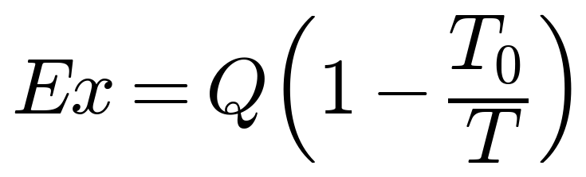
directly derived from the Carnot efficiency of an ideal heat engine operating between T and T₀: the term (1 − T₀/T) is exactly that Carnot efficiency, so Ex is “the work a perfect heat engine could extract from Q before discarding the rest to the environment at T₀.”
The practical consequence is that low-temperature heat has low exergy — there is little useful work left to extract — and forcing it through a high-temperature process (or delivering it at a temperature far above what the end use actually needs) destroys exergy for no benefit. Matching source temperature to demand temperature, which is precisely what 5GDHC’s near-ambient loop plus building-level WSHP boosting achieves, minimises this destruction. This is the rigorous version of the intuitive claim in Part 1 §1.5 that “low-temperature sources possess low exergy” and that matching them to low-temperature demand “minimises exergy destruction.”

4.2 Worked example
Take a reference environment at T₀ = 10 °C (283.15 K) and 1 kWh of heat delivered at three representative network temperatures:
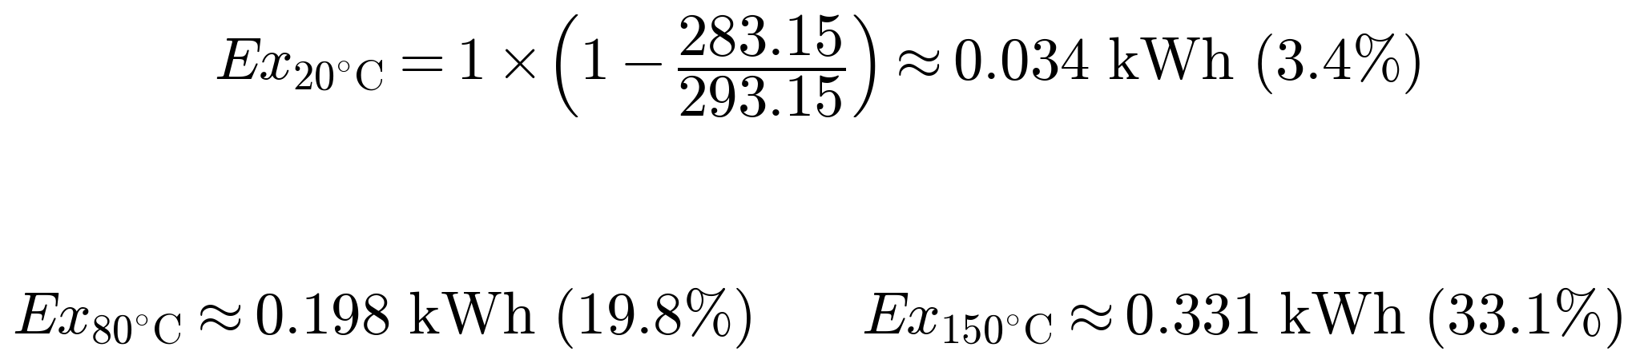
only about 3.4% of the 5GDHC heat's energy content is exergy (available work); the rest is low-grade warmth well matched to space heating, versus roughly 19.8% for 3GDH and 33.1% for 1GDH. Delivering 1 kWh of space-heating demand (which needs only low-exergy warmth) via 1GDH steam therefore destroys roughly ten times more exergy than delivering the same 1 kWh via a 5GDHC ambient loop — exergy that was available to do other useful work (electricity generation, higher-temperature process heat) before being spent on a duty that never needed it.

5. Hydraulic Losses and the Physical Basis for Meshing

5.1 Derivation
Pressure drop along a pipe run is commonly estimated with the Darcy–Weisbach equation:
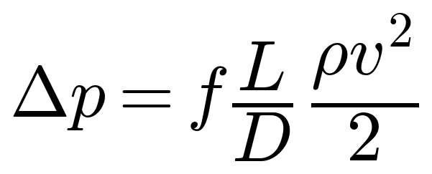
where f is the (dimensionless) Darcy friction factor, L is pipe length, D is internal diameter, ρ is fluid density, and v is mean flow velocity. The friction factor f itself depends on the Reynolds number and pipe roughness (via the Colebrook–White equation for turbulent flow, or the laminar relation below); district-heating pipe flows are almost always turbulent, so f is commonly taken in the range 0.015–0.03 for typical steel or plastic pipe at the velocities and diameters involved, and is treated here as a fixed illustrative value rather than derived from first principles.
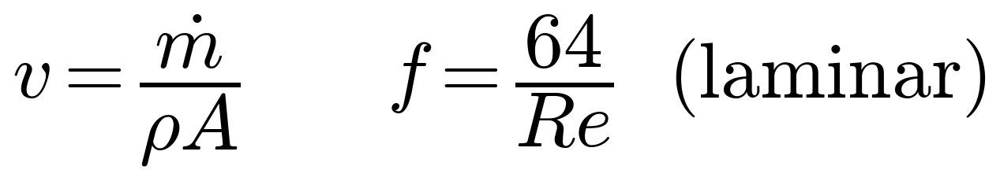
The formula's structural implication is what matters for network design: pressure drop scales with the square of velocity, and velocity itself is v = ṁ/(ρA) for a given mass flow and pipe cross-section A. Combined with §1's result that low-ΔT operation requires higher mass flow for the same delivered power, this means pressure drop (and hence pumping energy) can rise very sharply as network ΔT falls — unless the higher mass flow is spread across more or larger parallel paths. That is the physical mechanism behind Part 1 §1.4's claim that meshed topologies “allow smaller individual pipe sections and lower velocities per branch, offsetting the higher mass-flow rates required by low-ΔT systems.”

5.2 Worked example: single path vs. meshed
Continuing the 1 MW example from §1.2, assume a DN150 branch pipe (internal diameter D = 0.15 m), a 500 m run, hot-water density ρ ≈ 980 kg/m³, and an illustrative friction factor f = 0.02. At the 3GDH condition (ṁ ≈ 7.97 kg/s, ΔT = 30 K):
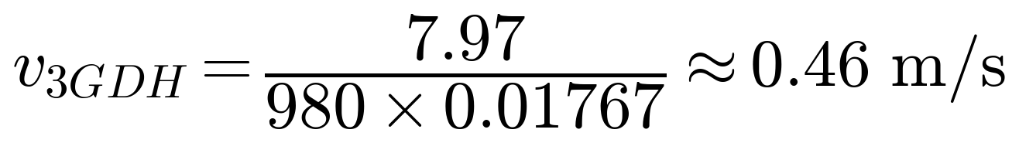
a modest, easily pumped loss.
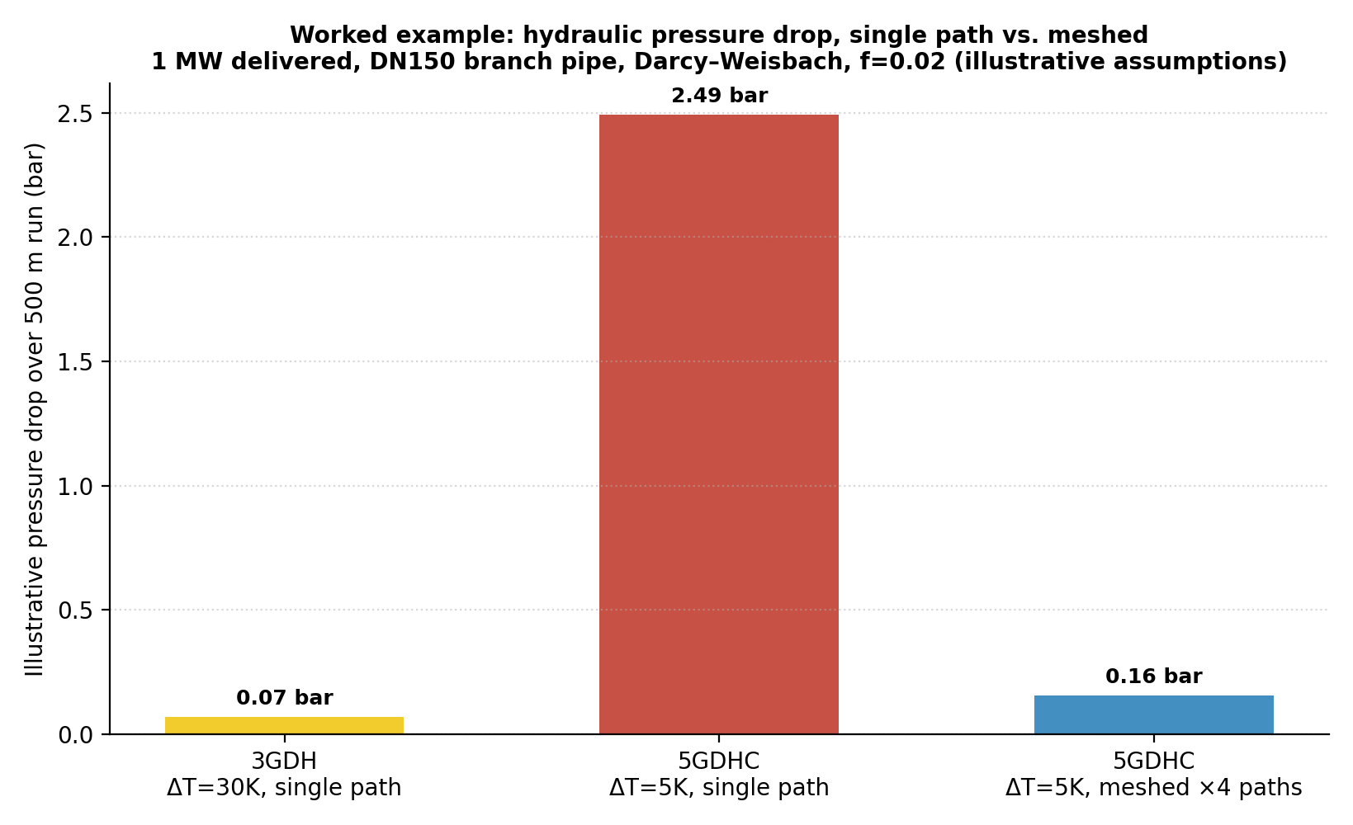
Figure 3. Worked, assumption-explicit comparison of hydraulic pressure drop for the same 1 MW delivered through a 500 m, DN150 branch: 3GDH at ΔT=30K on a single path; 5GDHC at ΔT=5K forced through the same single path; and 5GDHC at ΔT=5K split across four meshed parallel paths. Source: author’s calculation using the Darcy–Weisbach relation in §5.1, with the stated illustrative assumptions.
Forcing the same 1 MW through the same single DN150 pipe at the 5GDHC condition (ṁ ≈ 47.8 kg/s, ΔT = 5 K):
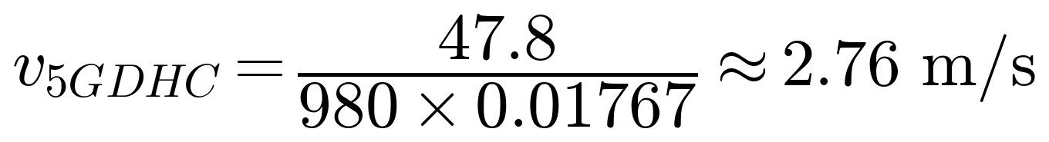
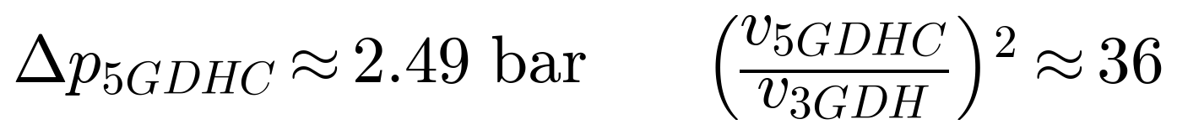
six times the 3GDH velocity, and since pressure drop scales with v², roughly 36 times the pressure drop — an impractically large pumping penalty for a single pipe. Splitting that same mass flow across four meshed parallel paths of the same diameter quarters the mass flow per branch and therefore the velocity per branch:
still somewhat higher than the 3GDH case (because total mass flow is still six times greater), but reduced from an impractical 2.49 bar to a manageable 0.16 bar by topology alone, without changing pipe diameter, insulation, or any other physical parameter. This is the quantitative substance behind Part 1 §1.4's claim that meshing is “a structural condition,” not an optional refinement, for low-ΔT networks: the numbers above show why a 5GDHC network built as a single radial trunk would not be hydraulically viable at this scale, while the same network meshed into a small number of parallel branches is.

6. Synthesis
The five relations above are not independent design choices; they interact. Lowering network temperature (T_f, entering the loss formula in §2 and the COP formula in §3) simultaneously reduces distribution losses, raises achievable heat-pump COP, and reduces exergy destruction — the three thermodynamic benefits Part 1 attributes qualitatively to 5GDHC. But the same move toward low ΔT that makes those gains possible (§1) forces higher mass flow for a given delivered power, which §5 shows translates into sharply higher pumping losses unless the network topology compensates by spreading that flow across meshed parallel paths. None of the five formulas in isolation explains why 5GDHC requires meshing; only tracing a single worked numerical example (as this document does, using a consistent 1 MW / DN150 / 500 m case throughout §1, §2, §3 and §5) shows that the topological requirement in Part 1 §1.4 is a direct, quantifiable consequence of the same thermodynamic equations that make 5GDHC attractive in the first place.
Table 6.1 collects the worked-example results from this document in one place for reference.
Quantity | 1GDH (≈150 °C) | 3GDH (≈80 °C) | 5GDHC (≈20 °C) | Source
Distribution heat loss (illustrative, W/m) | 34.1 | 17.1 | 2.4 | §2.2
Mass flow for 1 MW at stated ΔT (kg/s) | n/a (steam) | 7.97 (ΔT=30K) | 47.8 (ΔT=5K) | §1.2
Pressure drop, single DN150 path, 500 m (bar) | n/a (steam) | 0.07 | 2.49 | §5.2
Pressure drop, 5GDHC meshed ×4 paths (bar) | — | — | 0.16 | §5.2
Exergy content of 1 kWh delivered (kWh, T₀=10°C) | 0.331 | 0.198 | 0.034 | §4.2

All figures in this table are illustrative parametric results under the stated assumptions (§2.2, §3.2, §4.2, §5.2), reproducible from the formulas in §1–§5 with project-specific inputs substituted in. They are not measured field data and should not be cited as such; they exist to make the qualitative claims already made in Part 1 checkable.

Conclusion
This document adds nothing to the historical, classificatory, or advocacy content of the Union Centrale programme — that material is already complete in Part 1 and is deliberately not repeated here. What it adds is traceability: every thermodynamic and hydraulic claim in Part 1 §1.5 and §1.4 now has, in this companion, a derivation from first principles and at least one worked numerical example a reader can reproduce or adapt with their own project data. Read together, Part 1 makes the technical and policy case for 4GDH/5GDHC and UTES; this document supplies the arithmetic underneath it.

Annex A — References
This annex is deliberately short: it covers only the thermodynamics and hydraulics literature underlying §1–§5. For district-heating history, generation classification, UTES, PVT, refrigerants, and policy references, see Part 1, Annex A (Document ID UC-DHC-UTES-EN-2026, Rev. 3-C).
- Lund, H., Werner, S., Wiltshire, R., Svendsen, S., Thorsen, J.E., Hvelplund, F. & Mathiesen, B.V. (2014). ‘4th Generation District Heating (4GDH): Integrating smart thermal grids into future sustainable energy systems.’ Energy, 68, 1–11. https://doi.org/10.1016/j.energy.2014.02.089 (source of the heat-transport and distribution-loss formulas extended in §1–§2).
- Buffa, S., Cozzini, M., D’Antoni, M., Baratieri, M. & Fedrizzi, R. (2019). ‘5th generation district heating and cooling systems: A review of existing cases in Europe.’ Renewable and Sustainable Energy Reviews, 104, 504–522. https://doi.org/10.1016/j.rser.2018.12.059
- Werner, S. (2017). ‘International review of district heating and cooling.’ Energy, 137, 617–631. https://doi.org/10.1016/j.energy.2017.04.045
- İncropera, F.P., DeWitt, D.P., Bergman, T.L. & Lavine, A.S. Fundamentals of Heat and Mass Transfer. Wiley (any recent edition) — standard reference for the cylindrical-conduction derivation in §2.1.
- Çengel, Y.A. & Boles, M.A. Thermodynamics: An Engineering Approach. McGraw-Hill (any recent edition) — standard reference for the Carnot COP and exergy derivations in §3.1 and §4.1.
- White, F.M. Fluid Mechanics. McGraw-Hill (any recent edition) — standard reference for the Darcy–Weisbach equation and friction-factor correlations (including Colebrook–White) used in §5.1.
- EN 14511 and EN 14825 — heat-pump COP, SCOP and SEER test methods, referenced for the real-machine efficiency context in §3.1.
- Part 1 (companion document): UC-DHC-UTES-EN-2026, Rev. 3-C, “District Heating Networks, 5GDHC & UTES — Compiled Dossier,” François Dorléans, for the full district-heating history, generation classification, topology, UTES, PVT, refrigerant-selection, and policy content this document deliberately does not repeat.

Annex B — Acronyms and Symbols
Symbol / Acronym | Meaning
1GDH–5GDHC | First- to fifth-generation district heating (and cooling) systems — see Part 1 for full definitions
COP | Coefficient of Performance
cₚ | Specific heat capacity at constant pressure (J/kg·K)
D | Pipe internal diameter (m)
Ex | Exergy (kWh or J)
f | Darcy friction factor (dimensionless)
L | Pipe length (m)
ṁ | Mass flow rate (kg/s)
Q, Q̇ | Heat quantity (kWh/J) or heat flow rate (W)
r | Pipe outer radius (m)
R_total | Total thermal resistance per unit pipe length (m·K/W)
Re | Reynolds number (dimensionless)
T_f, T_g, T₀ | Fluid temperature, ground temperature, reference environment temperature (K or °C)
U | Overall heat-transfer coefficient (W/m²·K)
v | Mean flow velocity (m/s)
W_el | Electrical power consumption (W)
Δp | Pressure drop (Pa or bar)
ΔT | Temperature difference, typically supply−return or hot−cold (K)
δ | Insulation thickness (m)
η_Carnot | Second-law (Carnot) efficiency of a real heat pump relative to the ideal cycle
λ_ins | Insulation thermal conductivity (W/m·K)
ρ | Fluid density (kg/m³)

Index
Revision History 2
0. Purpose, Scope and Relationship to Part 1 3
1. Heat Transport and Energy Balance 3
1.1 Derivation 3
1.2 Worked example 4
2. Distribution Heat Losses 5
2.1 Derivation 5
2.2 Worked example: distribution loss by generation 6
3. Heat-Pump Performance: Carnot and Real COP 7
3.1 Derivation 7
3.2 Worked example 8
4. Exergy: Quantifying “Low-Grade” Heat 9
4.1 Derivation 9
4.2 Worked example 9
5. Hydraulic Losses and the Physical Basis for Meshing 10
5.1 Derivation 10
5.2 Worked example: single path vs. meshed 10
6. Synthesis 12
Conclusion 12
Annex A — References 13
Annex B — Acronyms and Symbols 14
Index 15

