District Heating Networks, Fifth-Generation Heating & Cooling (5GDHC), and Underground Thermal Energy Storage (UTES)
A Compiled Technical and Advocacy Reference — History, Thermodynamics, Network Topology, and the 2026 State of the Art for Europe and Africa

District Heating, 5GDHC & UTES — Compiled Dossier
Author / Content Owner: François Dorléans
AI transparency: this English edition was compiled, translated, and typeset with AI assistance (Claude, Anthropic) from source dossiers authored by François Dorléans — the district-heating/5GDHC history dossier, the UTES Europe/Africa 2026 state-of-the-art dossier, and, for Section 2.5, the PVT heating and cooling dossier. Revision 2-C content was cross-checked against a parallel compilation of the same three dossiers produced with a different AI assistant; only material traceable to the citations in Annex A was carried across. Revision 3-C added an editorial clarification on 4GDH/5GDHC complementarity and a new subsection on heat-pump refrigerant selection, both grounded in the peer-reviewed and IEA sources listed in Annex A. All factual content is grounded in those citations; figures were drawn or redrawn for this edition and are referenced to their underlying sources in each caption.

Document ID: UC-DHC-UTES-EN-2026
Revision: 3-C
Version date: 04/09/2026 (Rev. 3-C)
Keywords: district heating, 5GDHC, meshed networks, UTES, PTES, ATES, BTES, GeoTES, seasonal thermal storage, geothermal, PVT, water-source heat pump, refrigerant selection, high-temperature heat pump, COP, Union Centrale

Revision History
Revision 1-C — Initial compiled English-language edition. Merges two previously separate source dossiers — “History of Urban District Heating Networks & 5GDHC” (updated August 2026) and “Stockage d’énergie thermique souterrain — UTES, état de l’art Europe/Afrique 2026” (3 September 2026) — into a single reference document. Full translation of the UTES dossier from French to English; harmonisation of terminology (UTES/LTES/PTES/ATES/BTES/MTES/CTES/TTES/GeoTES) across both source texts; addition of eight referenced diagrams (generational timeline, hydraulic topologies, COP curve, UTES efficiency and CAPEX ranges, PTES site inventory, three-pillars integration schematic, advocacy calendar); consolidation of the two separate reference lists and acronym indices into single Annexes A and B; construction of a page-accurate index.
Revision 2-C — Cross-check against a parallel English compilation of the project’s three working dossiers (“Heat and Cold Are Energy,” September 2026 compilation, produced with a different AI assistant) that additionally drew on the third source dossier, Solutions_Chauffage_Refroidissement_PVT_Europe_Afrique_2026, not previously supplied to this edition. Added new Section 2.5, “PVT Collectors and Water-Source Heat Pumps,” covering IEA SHC Task 60, manufacturer-published SCOP/SPF figures (Triple Solar, DualSun — labelled as manufacturer claims, distinct from independent measurement), and the PVT/UTES stranded-summer-heat link; renumbered Sections 2.5–2.9 to 2.6–2.10 accordingly. Added four new referenced diagrams — PTES pit cross-section, PVT + water-source heat pump energy-flow schematic, UTES taxonomy by geological depth, and an Africa thermal-cascade schematic — redrawn in this document’s own style rather than reproduced from the source file. Figure captions now auto-number in document order. Added exact EU directive numbers for the EED (2023/1791) and EPBD (2024/1275) in Annex A.4, a new Annex A.3 for PVT/heat-pump references, and SCOP/UIOM to Annex B. Two AI-generated illustrative renderings in the cross-checked compilation were reviewed and not reproduced here, as they carry no additional technical or referencing value beyond the schematic diagrams already included.
Revision 3-C — Editorial review pass: added Section 1.3.1, ‘4GDH and 5GDHC: Parallel, Not Sequential, Generations,’ clarifying — with Lund et al. (2021, Energy 227, 120520) and the Danfoss source already cited in Annex A.1 — that the two generations are complementary architectures rather than a sequential progression; added Section 2.5.4, ‘Working-Fluid Selection and the Temperature-Dependent Efficiency Ceiling,’ distinguishing the heat pump’s refrigerant from its water/brine carrier loop and setting out the delivery-temperature crossover (below ≈100–120°C, natural refrigerants such as ammonia, propane and CO₂ outperform water as refrigerant; above it, water/R718 and R717/R718 cascades take over), per IEA HPT Annex 58 and Wu et al. (2020, Renewable Energy 154, 715–722). Added two new referenced diagrams — a 4GDH-backbone/5GDHC-ambient-loop schematic and an illustrative refrigerant-efficiency-crossover chart — and cross-linked the two new sections to each other and to the existing Sections 1.3, 2.5, 2.8 and Part III. Added Lund et al. (2021) to Annex A.1; renamed Annex A.3 to ‘PVT collectors, heat pumps and refrigerants’ and added the Annex 58 and Wu et al. citations; added HTHP and MVR to Annex B.
Source lineage retained for traceability: District_Heating_Networks_History_5GDHC_Dossier_Updated (Generic Technical Dossier, August 2026 update); Stockage_Thermique_UTES_Etat_de_l_Art_Europe_Afrique_2026 (Document de travail, 3 September 2026); and, for Section 2.5 only, Solutions_Chauffage_Refroidissement_PVT_Europe_Afrique_2026 (August 2026), all authored by François Dorléans.

Executive Summary
Heat and cold are energy. A thermal kilowatt-hour (kWhₑₕ) is as much a unit of energy as an electrical one: it can be stored, moved through a network, and delivered to a building, a greenhouse, or an industrial process. Heating and cooling account for roughly half of final energy demand in the European Union, and remain largely covered by gas, fuel oil, and coal. Moving Europe and Africa out of that dependence requires two things simultaneously: distribution infrastructure capable of carrying low-exergy heat efficiently, and storage infrastructure capable of shifting that energy from a season, a day, or a process where it is a surplus to one where it is a need.
This compiled dossier brings together two previously separate technical references. The first traces the 150-year history of urban district heating, from Roman hypocausts and the 1334 Chaudes-Aigues network through four defined generations (1GDH–4GDH, following Lund et al., 2014) to Fifth-Generation District Heating and Cooling (5GDHC, Buffa et al., 2019), and establishes why meshed (grid) hydraulic topologies are a structural requirement — not an optional refinement — for low-temperature, bidirectional networks, especially on flat terrain. The second sets out the 2026 state of the art in underground thermal energy storage (UTES), anchored on the IEA Geothermal / IEA Energy Storage TCP / GEOTHERMICA / TREASURE corpus published in September 2026, covering pit (PTES), aquifer (ATES), borehole (BTES), mine-water (MTES), cavern (CTES), tank (TTES), and deep geological (GeoTES) storage.
Read together, the two dossiers describe a single system with three functions: capture low-exergy heat (geothermal, PVT hybrid panels, industrial waste heat, seasonal electricity surplus), store it underground across days to seasons, and distribute it through a meshed 4GDH/5GDHC network. Remove the storage function and a well-designed low-temperature network still buys fossil thermies on cold days in January. Remove the meshed network and stored energy has no efficient path to the point of use. This document treats both halves as one dossier because the policy and engineering case for either is materially strengthened by the other.

Part I — History of Urban District Heating Networks and 5GDHC

1.1 Historical Origins and Early Developments
Antecedents of organised heat distribution can be traced to antiquity. Roman hypocaust systems and heated baths used underfloor and wall channels to move warm air and water through buildings. A more direct precursor appeared at Chaudes-Aigues, France, around 1334, where geothermal hot water was distributed through wooden pipes to approximately thirty houses — widely regarded as the earliest documented operational district heating arrangement.
Commercial modern district heating (DH) began in North America. In 1877, hydraulic engineer Birdsill Holly established the first commercially successful steam-based district heating system in Lockport, New York. The New York Steam Company began service in Manhattan in 1882, and that steam network remains operational today. Early systems also appeared at institutions such as the U.S. Naval Academy (1853) and later at MIT.
In Europe, commercial systems emerged later: Germany in the 1920s (initially steam-based), the Soviet Union from the 1930s (with rapid expansion in the 1950s), and China from the 1950s–1960s. Scandinavia developed significant systems from the early twentieth century onward — for example Vaasa, Finland (1902), Västerås, Sweden (1920), and the municipal plant at Karlstad (1948). Post-war reconstruction and the oil crises of the 1970s accelerated adoption, particularly of more efficient water-based systems.
By the late twentieth century, major concentrations of DH capacity existed in Russia/CIS, China, and Northern/Eastern Europe. Global heat delivery via district heating reached approximately 11.5 EJ in the mid-2010s, with China, Russia, and the European Union accounting for the large majority of that total.

1.2 The Four Generations of District Heating (1GDH–4GDH)
The generational classification, introduced and refined by researchers including Lund, Werner and colleagues, reflects successive improvements in carrier temperature, materials, efficiency, and system integration.

1GDH — approximately 1880–1930
Carrier: steam at 120–200 °C. Pipes: steel, typically in concrete ducts or tunnels. Characteristics: high heat losses, safety risks from high pressure and temperature, condensation losses at the consumer. Examples: early U.S. systems (Lockport, Manhattan) and early European steam networks. Steam remains in limited high-density use today, including parts of New York and Paris.

2GDH — approximately 1930–1980
Carrier: pressurised hot water, generally above 100 °C. Motivation: improved efficiency through Combined Heat and Power (CHP) and reduced losses relative to steam. Infrastructure: heavier, site-insulated steel pipes and large substations. Widespread across the Soviet Union, Eastern Europe, and early Western European systems.

3GDH — approximately 1980–2020 (“Scandinavian” technology)
Carrier: pressurised water below 100 °C, often 70–90 °C supply. Key advances: factory-prefabricated, pre-insulated pipes; compact substations; improved metering and control; greater fuel flexibility including biomass and waste. Result: lower distribution losses, reduced capital and labour costs, and higher reliability. Most currently operating European networks belong to this generation or to transitional variants of it.

4GDH — emerging from approximately 2020
Defined by Lund et al. (2014) as low-temperature networks, typically 50–70 °C supply and sometimes lower, designed for compatibility with energy-efficient buildings; integration of low-grade renewable and residual heat (solar thermal, shallow geothermal, industrial waste heat, data-centre heat); reduced thermal losses; and operation as “smart thermal grids” within broader smart energy systems, interacting with electricity and gas grids, thermal storage, and demand response. It is at this generation that the choice of hydraulic topology — radial, looped, or meshed — becomes increasingly consequential for system performance and expandability.
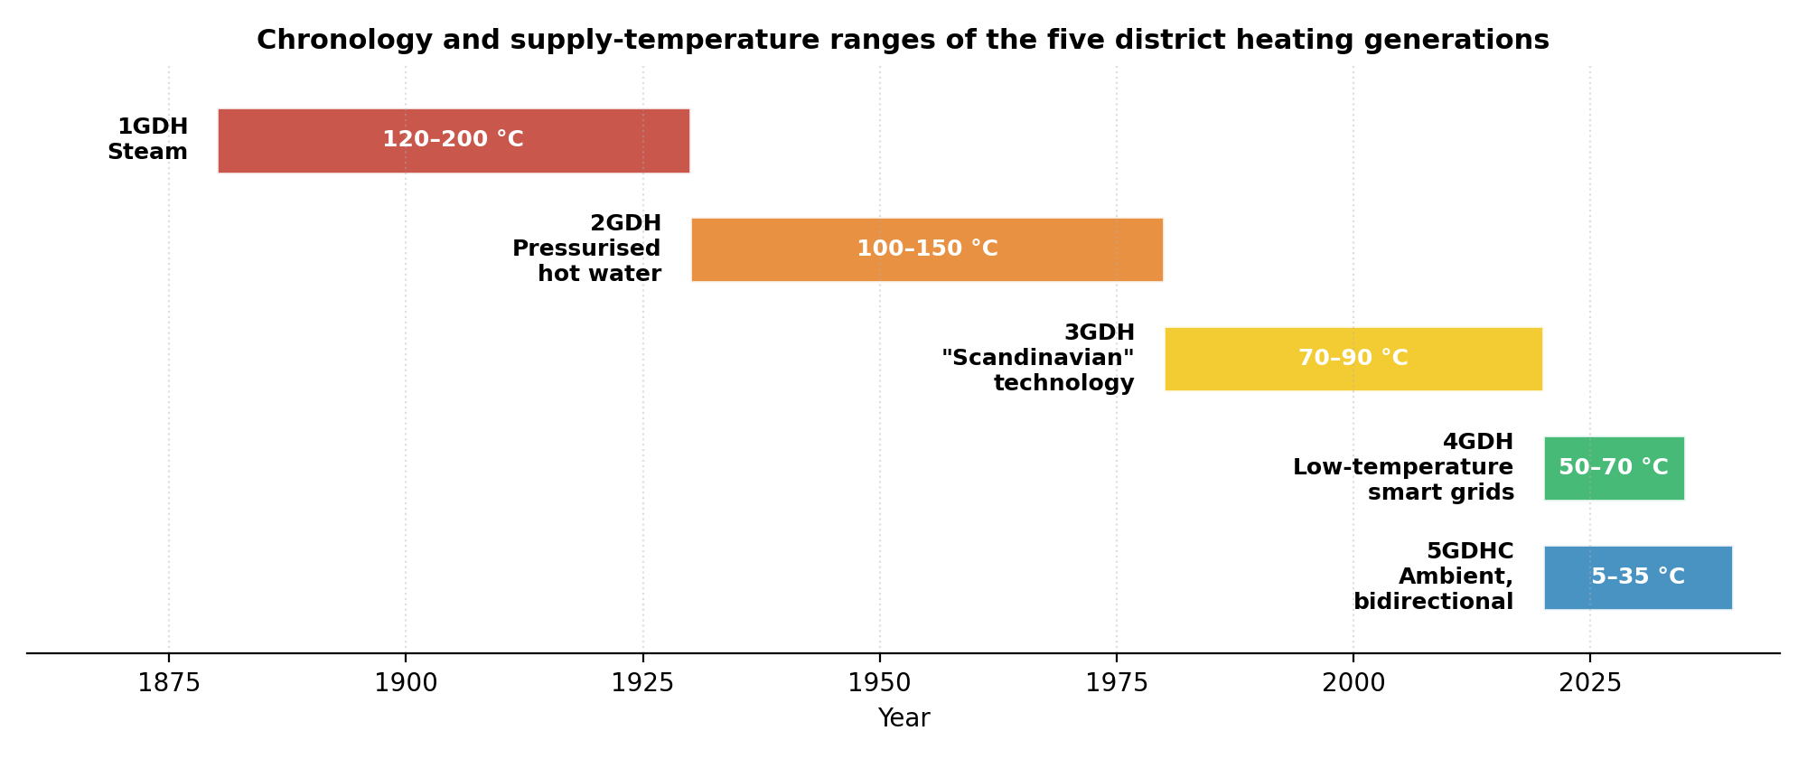
Figure 1. Chronology and supply-temperature ranges of the five district heating generations. Source: compiled from Lund, H. et al. (2014), “4th Generation District Heating (4GDH),” Energy, 68, 1–11; Werner, S. (2017), “International review of district heating and cooling,” Energy, 137, 617–631; Buffa, S. et al. (2019), Renewable and Sustainable Energy Reviews, 104, 504–522.

1.3 Fifth-Generation District Heating and Cooling (5GDHC)
5GDHC — also referred to in the literature as cold district heating, anergy grids, or ultra-low-temperature networks — was systematically reviewed and defined by Buffa et al. (2019). Their widely cited formulation describes a 5GDHC network as a thermal energy supply grid using water or brine as carrier medium and hybrid substations equipped with Water Source Heat Pumps (WSHP), operating at temperatures close enough to ground temperature that the carrier is not suitable for direct heating. The low temperature of the carrier allows direct exploitation of industrial and urban excess heat and of renewable heat sources with low thermal exergy content; reversing the operation of customer substations allows the same pipe infrastructure to cover both heating and cooling demand simultaneously.
Core characteristics of 5GDHC include near-ambient network temperatures (commonly 5–30 °C, sometimes up to approximately 40 °C); bidirectional or multi-directional energy flows in which buildings act as prosumers, able to supply or extract heat and cold; decentralised WSHPs or reversible heat pumps at customer substations that boost or reject temperature as needed; a single pipe network serving both heating and cooling; high compatibility with low-exergy sources such as shallow geothermal, wastewater, ambient water, and excess heat from data centres or refrigeration; and frequent integration of seasonal thermal storage (ATES, BTES, or pit storage) for balancing — the direct link to Part II of this dossier.
Because temperature differences relative to the ground are small in 5GDHC, distribution heat losses are minimal, and under certain conditions can even become gains. Insulation requirements are correspondingly reduced, and plastic pipes become viable. These characteristics make hydraulic topology, and in particular the degree of meshing, a first-order design parameter rather than a secondary detail.

1.3.1 4GDH and 5GDHC: Parallel, Not Sequential, Generations
The generational labels used throughout this dossier can invite a misreading: that 5GDHC is simply what 4GDH becomes once it matures, and that a network should progress from one to the other. The reference literature is explicit that this is not the intended reading. Lund, Werner, Thorsen, Gudmundsson and colleagues — the same authors who defined 4GDH in 2014 — revisited the question in 2021 and concluded that 5GDHC should be understood as a parallel development, not a sequential one: it shares 4GDH’s core objectives (renewable integration, low losses, smart operation) but is better described as a sibling technology within the broader 4GDH family than as a fifth stage superseding a fourth. Their comparative work, echoed in the Danfoss technical literature already cited in Annex A.1, further shows that 4GDH remains the more cost-effective and more resilient choice for many existing, higher-density networks, while 5GDHC’s advantages concentrate in new-build clusters, mixed heating-and-cooling loads, and sites with strong bidirectional prosumer potential.
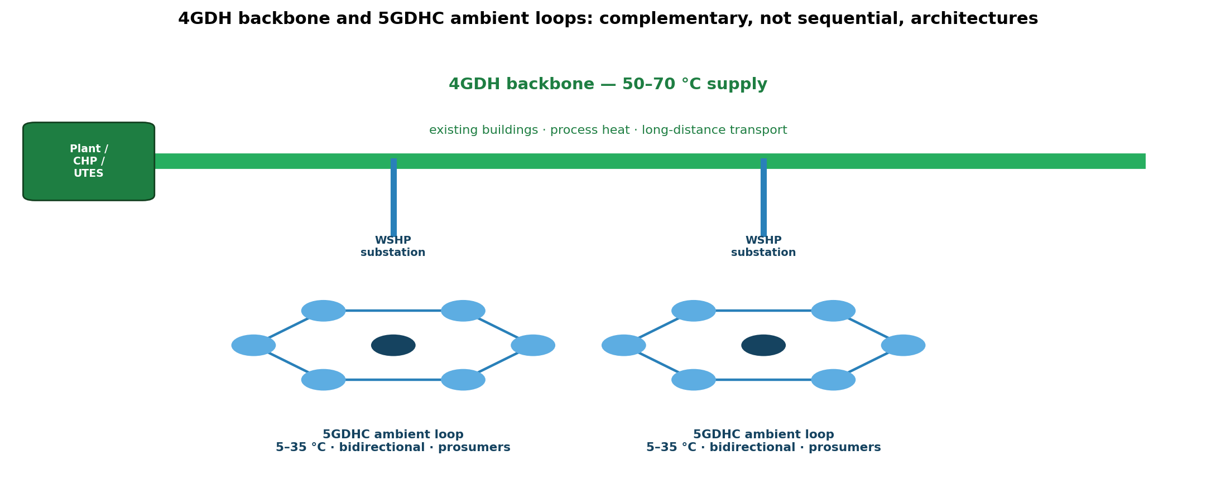
Figure 2. A 4GDH backbone (50–70 °C, serving existing buildings, process heat, and long-distance transport) with 5GDHC ambient loops (5–35 °C, bidirectional, prosumer-served) branching off through WSHP substations. The two architectures are complementary layers of the same network rather than successive replacements. Source: author’s schematic, after Lund, H. et al. (2021), ‘Perspectives on fourth and fifth generation district heating,’ Energy, 227, 120520.
Practically, this means a system operator does not need to choose 4GDH or 5GDHC as a strategic destination. A dense existing network already carrying 60–70 °C water to older buildings and industrial customers can retain a 4GDH backbone, while new districts, greenhouse clusters, or data-centre-adjacent developments are served by meshed 5GDHC loops fed from the same backbone through WSHP substations — the architecture illustrated above. Section 2.5.4 below shows that this split also has a physical basis: the heat-pump working fluid that delivers the best efficiency differs between the two temperature regimes.

1.4 Network Topologies and the Strategic Importance of Meshing
The hydraulic architecture of a district heating or cooling network is not a secondary detail. It directly determines resilience, the distribution of pressure drop, the ability to integrate multiple sources and prosumers, and the practical performance of low- and ultra-low-temperature systems. Three principal topologies are in use.
Radial (arborescent / tree-like): a single path runs from production to each consumer. Simple and lower capital cost, but it creates single points of failure, difficult hydraulic balancing, and limited capacity to accept new sources or prosumers without major redesign.
Looped (ring): closed loops allow flow to be redirected in case of interruption, giving better redundancy than a pure radial system, though still constrained in dense, multi-source configurations.
Meshed (grid): multiple parallel paths connect nodes in a grid. This gives the highest redundancy, natural flow distribution, and superior ability to accommodate bidirectional exchanges and distributed sources — the topology best aligned with the requirements of 4GDH and, especially, 5GDHC.
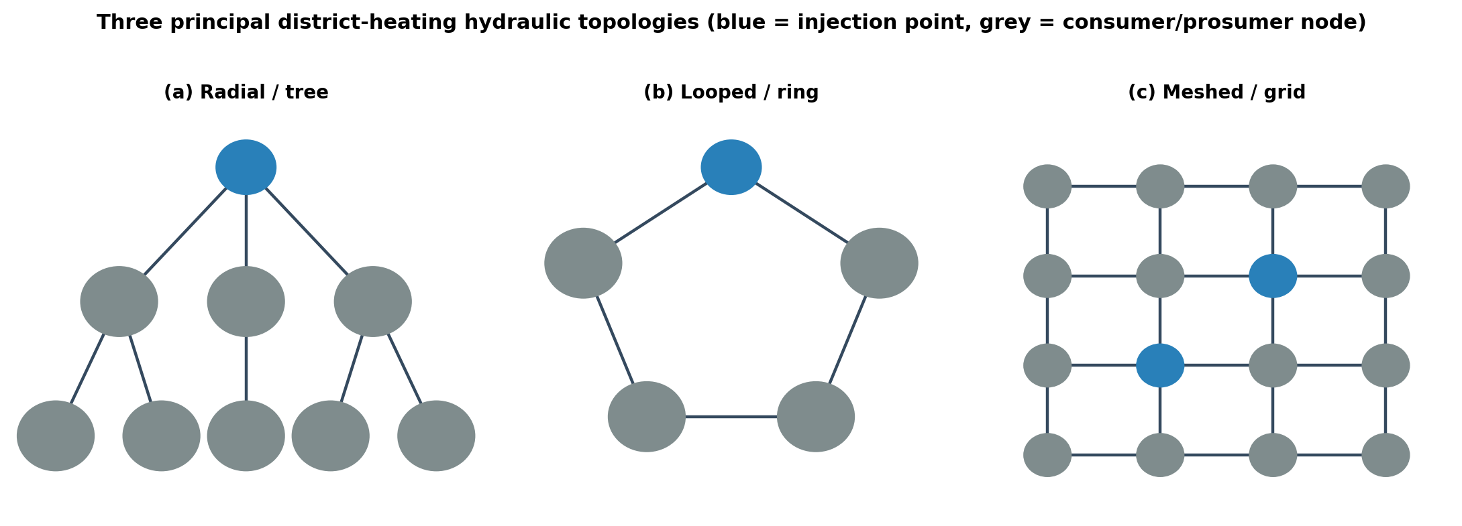
Figure 3. The three principal district-heating hydraulic topologies: radial, looped, and meshed. Source: author’s schematic, based on the topology classification in the district-heating history dossier (August 2026 update), consistent with DHC+ Technology Platform and D2Grids project descriptions of network architecture.

Why meshing becomes decisive in low-temperature and flat-terrain systems
In nearly flat terrain — dominant across large parts of North-Western Europe and many urban and peri-urban zones in Africa — static pressure differences due to elevation are negligible and friction losses dominate. Under these conditions, a meshed layout delivers decisive advantages: maximum resilience, since a pipe failure, maintenance intervention or pump outage does not isolate entire districts because alternative paths remain available; improved hydraulic balancing, as flows redistribute naturally across parallel branches, reducing cold spots and excessive pressure at network extremities; the ability to integrate multiple sources and prosumers, which is fundamental for 5GDHC, since each building, greenhouse or industrial process can inject or extract heat without creating bottlenecks; lower average pressure drop and pumping energy, because multiple paths allow smaller individual pipe sections and lower velocities per branch, offsetting the higher mass-flow rates required by low-ΔT systems; an optimal match with ambient-temperature (5–35 °C) networks, favouring local heat and cold exchange over long-distance transport of small temperature differences; and scalability, since new branches, prosumers, or residual/renewable sources can be connected without fundamentally redesigning the existing grid.
High-temperature radial networks (1GDH–3GDH) can function adequately with tree-like layouts. In contrast, 4GDH and especially 5GDHC systems — characterised by low ΔT, bidirectional flows, and multiple distributed sources and prosumers — require a high degree of meshing to realise their thermodynamic and operational potential. Without sufficient meshing, the theoretical advantages of ambient-temperature operation are partially cancelled by hydraulic constraints, single-point vulnerabilities, and limited expandability. Meshing is therefore a structural condition for successful large-scale deployment of the network generations that must carry the bulk of the transition away from hydrocarbon-based heating and cooling in dense and semi-dense areas.

1.5 Thermodynamic Foundations and Governing Equations
The progressive lowering of network temperatures across generations is driven by fundamental thermodynamic principles: reduced driving temperature differences decrease irreversible losses, improve the Coefficient of Performance (COP) of heat pumps, and lower distribution losses.

Heat transport and energy balance
The thermal power carried by a fluid stream is Q̇ = ṁ · cₚ · ΔT, where ṁ is the mass flow rate (kg/s), cₚ is specific heat capacity (J/kg·K), and ΔT is the temperature difference between supply and return (K). A lower ΔT requires a higher mass flow, or larger pipe diameters, for the same power — a key design trade-off that meshed topologies help manage by distributing flow across multiple paths.

Distribution heat losses
For a buried insulated pipe, radial heat loss per unit length is governed by conduction through cylindrical layers, commonly expressed as q̇_loss = 2π(T_f − T_g) / [(1/λ_ins)·ln((r+δ)/r) + R_other], or more generally as Q̇_loss = U·A·ΔT. Because ΔT is much smaller in 5GDHC than in 1–3GDH systems, absolute losses fall dramatically, often by 75% or more; meshing further supports this advantage by enabling shorter effective transport distances for local exchanges.

Heat-pump performance
The ideal Carnot Coefficient of Performance for heating is COP_Carnot,heating = T_hot / (T_hot − T_cold), with absolute temperatures in kelvin; for cooling, COP_Carnot,cooling = T_cold / (T_hot − T_cold). Real heat-pump performance is expressed as COP_real = η_Carnot · COP_Carnot, where η_Carnot typically ranges from 0.4 to 0.6. In 5GDHC the source temperature is close to ambient, so achievable COPs are high, frequently 4–8 or more. Electricity consumption follows as W_el = Q̇_heating / COP.
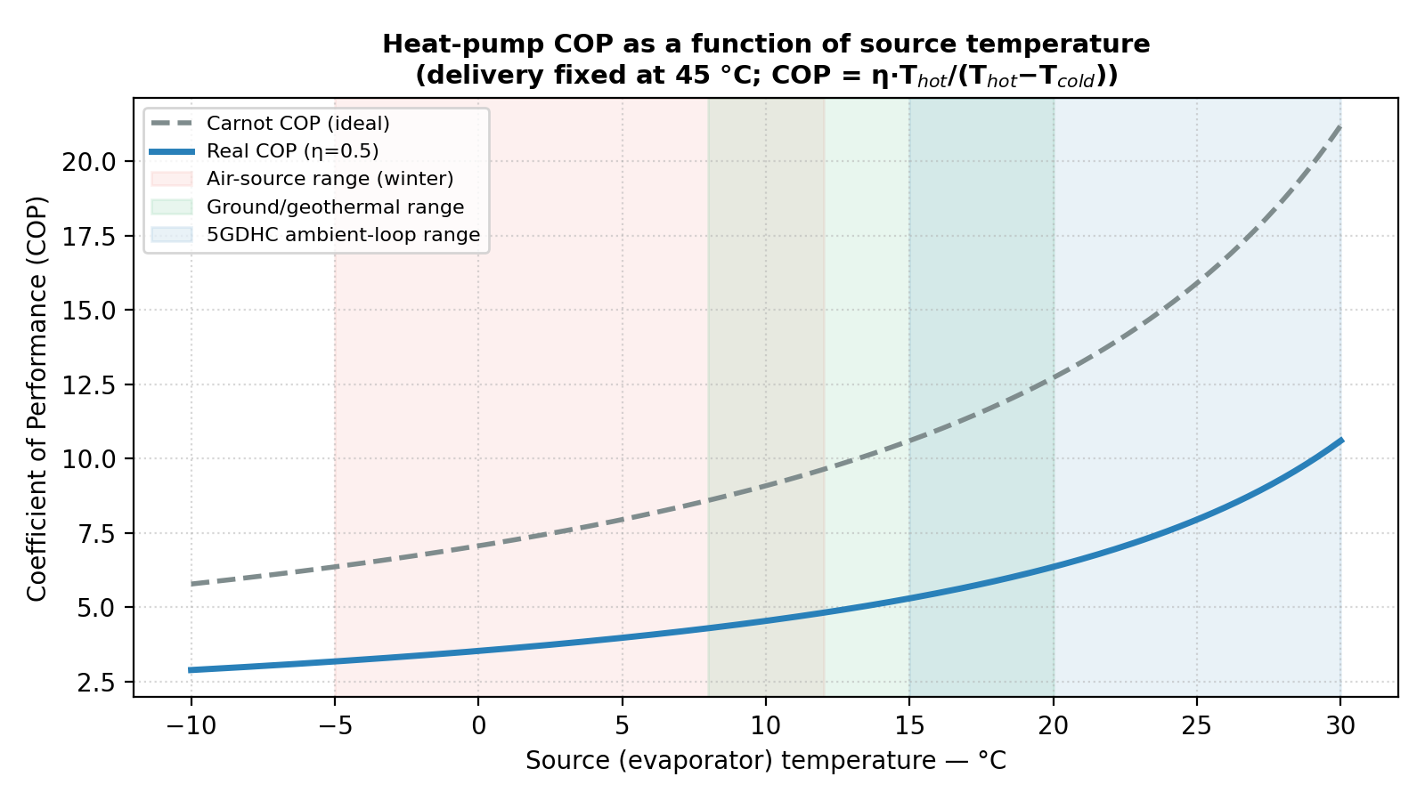
Figure 4. Heat-pump COP as a function of source temperature (delivery fixed at 45 °C). Curve computed from COP_Carnot = T_hot/(T_hot−T_cold) and COP_real = η·COP_Carnot with η = 0.5, per the governing-equations framework in the district heating history dossier and standard heat-pump thermodynamics (see also EN 14511/14825 test-condition context).

Exergy considerations
The exergy of a heat quantity Q at temperature T relative to the environment T₀ is Ex = Q(1 − T₀/T). Low-temperature sources possess low exergy; matching these sources to low-temperature demands via 5GDHC minimises exergy destruction, which is the central thermodynamic argument for ambient-temperature networks.

Hydraulic losses
Pressure drop is commonly calculated with the Darcy–Weisbach equation, Δp = f·(L/D)·(ρv²/2). Higher mass flows in low-ΔT systems increase pumping energy; meshed topologies mitigate this by offering multiple parallel paths, reducing average velocities and friction losses for a given total power transfer.

1.6 Global Status, Benefits and Challenges
Worldwide district heating capacity remains concentrated in China, Russia/CIS, and Europe. The transition from 3GDH toward 4GDH and pilot-scale 5GDHC is most advanced in Northern Europe and parts of Germany, Switzerland, and the Netherlands — notably the Mijnwater system in Heerlen, which uses mine-water geothermal resources and is discussed further in Part II. Benefits of lower-temperature generations include substantially reduced distribution losses, higher shares of renewable and residual heat, simultaneous heating and cooling service, and improved sector coupling with electricity systems via heat pumps.
Challenges include the need for building-side temperature compatibility, or booster heat pumps where this is absent; higher specific pumping energy in some configurations; institutional and regulatory frameworks for prosumer participation; and careful hydraulic design of bidirectional networks. Among these, insufficient meshing of the distribution grid is a frequent, under-recognised constraint that limits the realised performance of otherwise well-designed 4GDH/5GDHC systems.

Part II — Underground Thermal Energy Storage (UTES): State of the Art 2026

2.1 The IEA Geothermal 2026 Corpus
The entry point for this part of the dossier is a September 2026 post from IEA Geothermal: system-level energy storage is not an add-on but the flexibility mechanism that allows wind, solar, and other variable sources to be fully valorised. IEA Geothermal draws together 2026 work conducted with GEOTHERMICA, the IEA Energy Storage TCP, the British Geological Survey, the UK Mining Remediation Authority, and the UK Department for Energy Security and Net Zero.
Resource | Role in the state of the art
Witter et al., 2026 (npj Thermal Science & Engineering) | UTES taxonomy and TWhₑₕ potential by geological formation (GeoTES)
IEA ES TCP Task 45 — Large Thermal Energy Storage | Accelerating LTES in district heating networks: tools, KPIs, permitting, standards
IEA ES TCP Task 46 — AppESS | Matching applications to technologies on the demand side (heat, cold, mobility)
TREASURE (Horizon Europe, 2024–2027) | Industrialising PTES: 7 demonstrators / 5 countries, ~20 satellite projects, target >2,000 pits
GEOTHERMICA / HEATSTORE Guidelines | HT-ATES guidelines, European UTES workshops
IEA Geothermal Mine Water Expert Group (BGS) | Flooded-mine case studies: Gateshead, Bochum, Heerlen, Glasgow
Enerstock 2027 (CIC energiGUNE) | IEA ES TCP congress, Vitoria-Gasteiz, 6–8 October 2027

This corpus repositions thermal storage at the centre of the energy-flexibility debate. Heat stored in summer — solar thermal, PVT, waste heat, or converted electricity surplus — is energy available in winter. Cold stored in winter is cooling energy available in summer. It is the same service expected of any storage technology: shifting already-produced energy in time, at the efficiency and cost achievable in the subsurface.

2.2 Useful Physics: Storing Thermal Energy
Water, subsoil, and rock are sensible-heat media. Stored energy is given by Q = m·cₚ·ΔT, or for a water volume, Q = ρ·V·cₚ·ΔT. For water, ρ ≈ 1,000 kg/m³ and cₚ ≈ 4.18 kJ/kg·K; one cubic metre of water exploited over a 40 K swing (for example 90 °C → 50 °C) contains approximately 46 kWhₑₕ. A 250,000 m³ pit at ΔT = 40 K therefore represents on the order of 11–12 GWhₑₕ — roughly the energy equivalent of a small season of demand for a medium-sized district network, stored on site.
Seasonal round-trip efficiency is not a laboratory constant: it depends on the number of cycles, insulation quality (liner, floating cover, soil conductivity), set-point temperature, and whether a heat pump is used on discharge. The Danish Energy Agency’s Technology Data sheets (2025 update) record, for PTES, 80% efficiency over one annual cycle, 90% over two cycles, and up to 95% for short cycling. ATES typically falls between 67% and 90%. BTES, being more diffusive, sits lower — often 20–65% depending on hydrogeology and design — but remains relevant wherever land availability or aquifer conditions rule out a pit.
IEA ES TCP Task 45 defines LTES as sensible storage of at least 1 GWhₑₕ per year, at atmospheric pressure, capable of returning heat above 50 °C to a district network. This is the industrial object of the present dossier.

2.3 UTES Taxonomy 2026
The reference taxonomy compiled by Witter et al. (2026) distinguishes the storage families summarised below. All store thermal energy; they differ by medium, temperature, cost, and permitting regime.
Family | Medium | Useful T° | Seasonal η (indicative) | CAPEX (order of magnitude) | TRL
ATES (LT/HT) | Open aquifer | 10–90 °C (HT R&D ~125 °C) | 40–90% | <10 €/m³ · ~300 €/kW >2 MW | 9 / 7–8
BTES | Closed borehole field | 10–80 °C | 20–65% (70–80% if well designed) | 5–15 €/m³ · 0.6–3 €/kWhₑₕ | 8
PTES | Water pit + liner + floating cover | 10–95 °C | 80/90/95% (1/2/short cycle) | 20–50 €/m³ · 0.5–1.7 €/kWhₑₕ | 8–9
TTES | Above/semi-buried tank | 95–104 °C | 50–90% (short term) | 100–300 €/m³ · ~3 €/kWhₑₕ | 9
CTES | Rock caverns | up to 140 °C | variable | competitive where cavity exists | 7–8
MTES / Mine water | Flooded galleries | 20–80 °C | 50–60% (Freiberg); SPF up to 10 in heating+cooling | reuse of mining infrastructure | 6–8
GeoTES / RTES | Deep aquifers, depleted oil fields | 0–300+ °C | recovery >90% (models) | 0.018–0.239 $/kWhₑₕ | 5–7
Cold UTES | Same families, cooling mode | 0–15 °C | high if aquifer balanced | close to ATES/BTES | 8–9

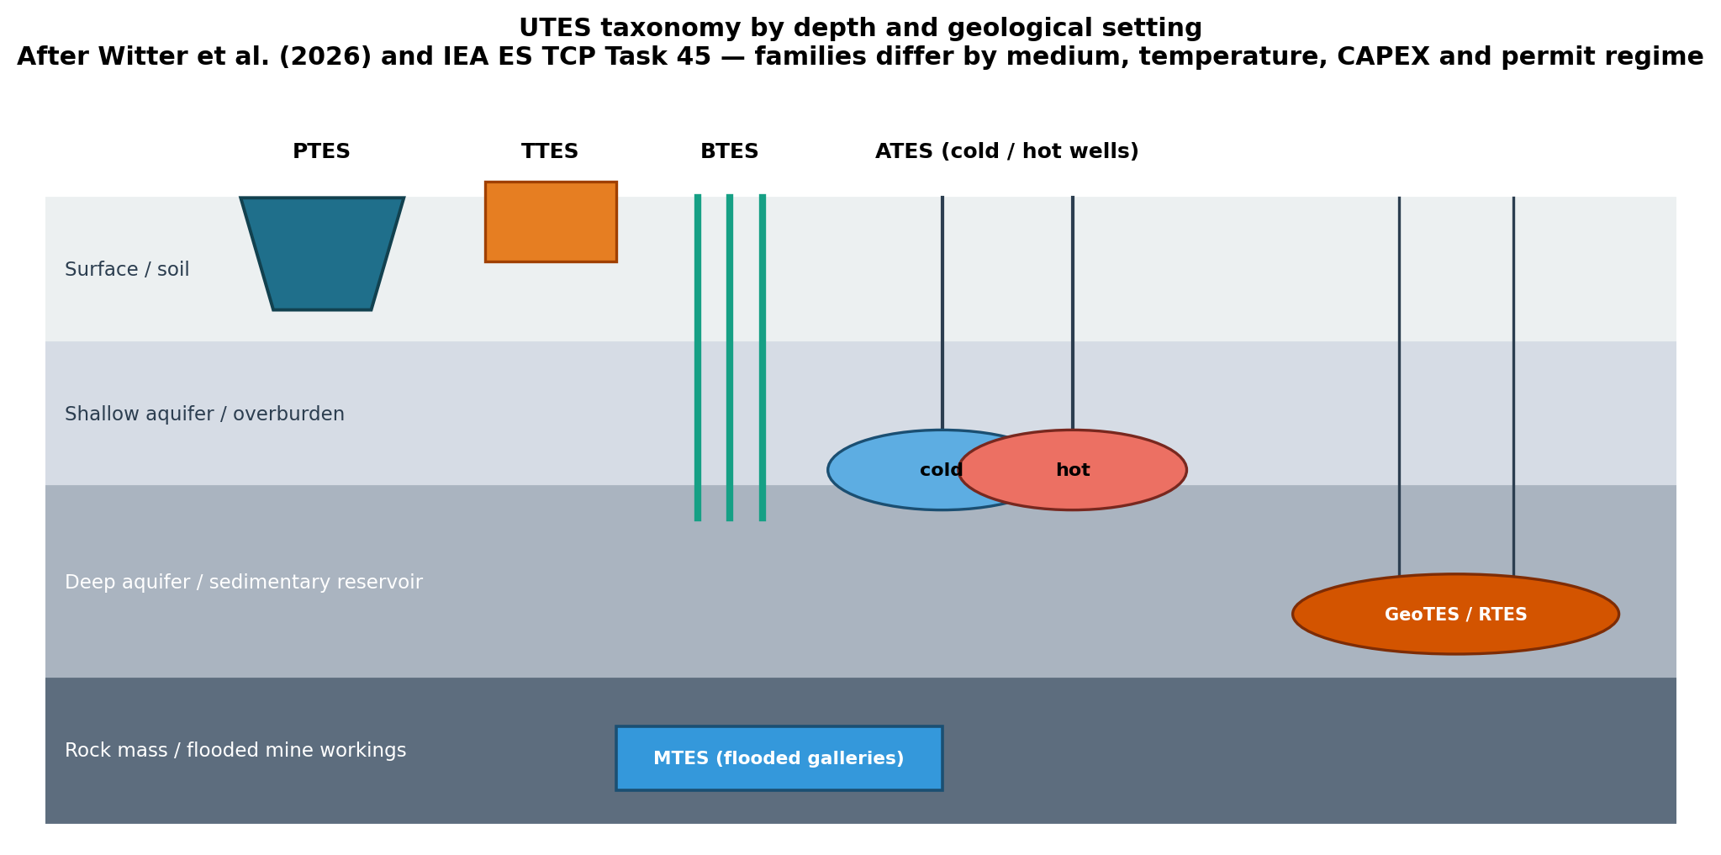
Figure 5. UTES taxonomy by depth and geological setting: pit (PTES) and tank (TTES) storage near the surface, borehole fields (BTES) and aquifer wells (ATES) at shallow-to-intermediate depth, deep geological/reservoir storage (GeoTES/RTES), and flooded mine galleries (MTES) within the rock mass. Source: author’s schematic after the Witter et al. (2026) taxonomy and the IEA ES TCP Task 45 definitions summarised in the table above.
Economic reading: the cost of a seasonally stored thermal kilowatt-hour in a pit or aquifer runs from tens of cents to a few euros. This is the effective cost of stored energy for space heating, greenhouse cooling, and low-to-medium-temperature process heat. The DEA’s 2024–2025 Technology Data revised PTES CAPEX upward by roughly 90% relative to older references to match realised prices at Høje Taastrup; current planning should therefore use 20–50 €/m³ depending on scale, geotechnics, and cover type, not the 15–20 €/m³ figures from the first generation of Danish pits.
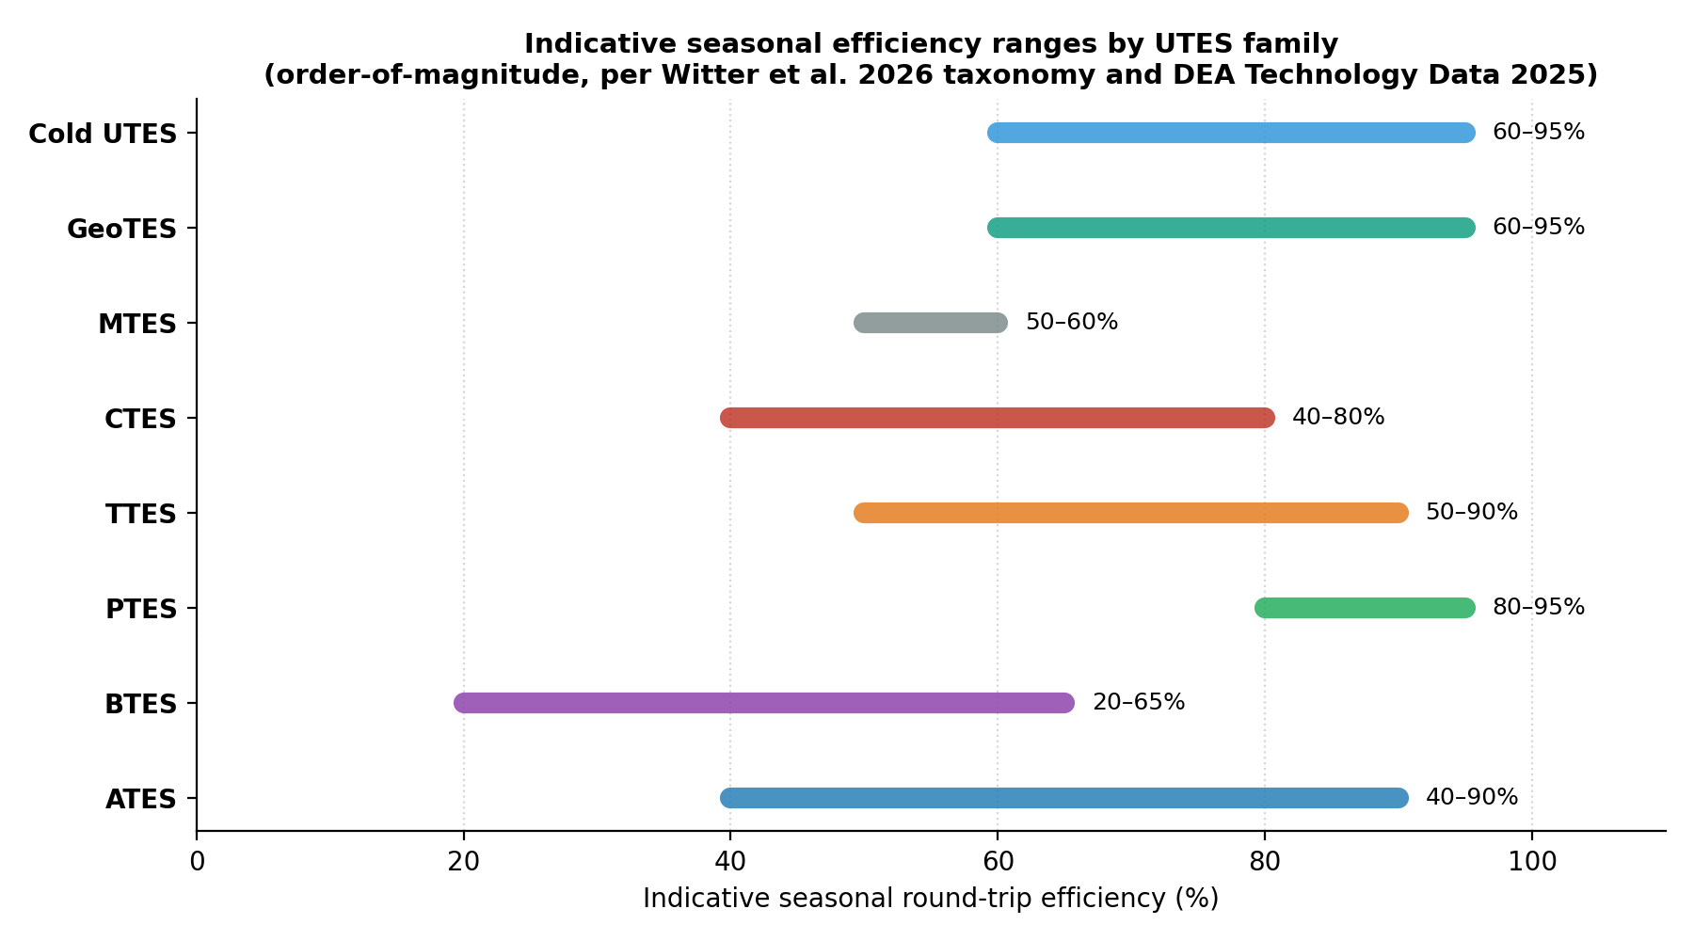
Figure 6. Indicative seasonal round-trip efficiency ranges by UTES family. Source: Witter, E., Akindipe, D., Zhu, G., McTigue, J. (2026), “Geological thermal energy storage offers terawatt-hours of energy storage capacity,” npj Thermal Science and Engineering; Danish Energy Agency, Technology Data for Energy Storage, 2024–2025 update.
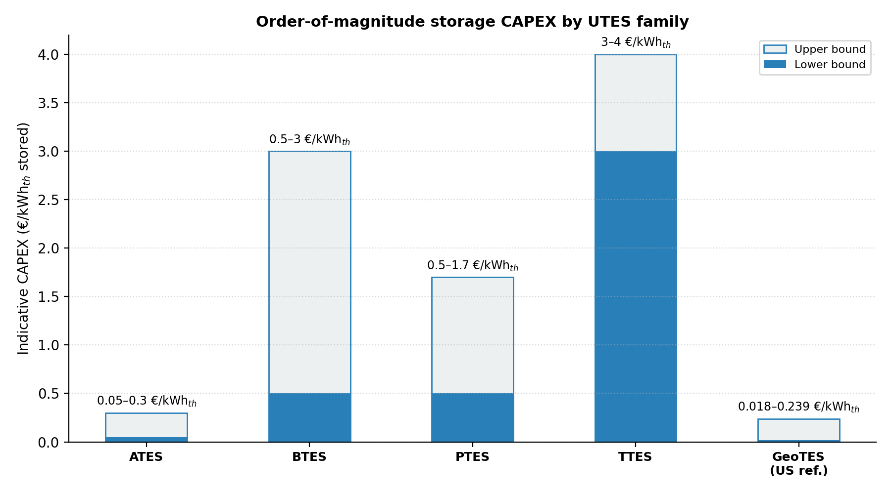
Figure 7. Order-of-magnitude storage CAPEX by UTES family. Source: Danish Energy Agency Technology Data (2024–25 update) for ATES/BTES/PTES/TTES; Witter et al. (2026) for GeoTES (US$ figures shown at parity for order-of-magnitude comparison, not currency-converted).

2.3.1 GeoTES: the deep-formation complement (Witter et al., 2026)
Witter, Akindipe, Zhu and McTigue (National Laboratory of the Rockies) estimate the potential of four U.S. formations — Antelope Hills and Belridge South in California, and Yegua-Jackson and Carrizo-Wilcox in Texas — at between 24 and 900 TWhₑₕ per formation, rising to several thousand TWhₑₕ at the upper bound for Carrizo-Wilcox. Well drilling cost is estimated at 0.75–1.25 M$; storage cost at 0.018–0.239 $/kWhₑₕ. A 1 TWhₑₕ system requires 24 to 190 wells — a pace compatible with the existing drilling industry. Candidate energy sources include solar thermal, electricity surplus, waste heat, and geothermal; candidate uses include district networks, 100–500 °C process heat (44% of U.S. industrial heat demand falls in this range), data-centre cooling, and binary-cycle electricity generation above 90 °C.
For Europe and Africa, the point is not to replicate Texan formations but that sedimentary reservoirs, late-life oil fields, and deep aquifers constitute a thermal energy stock at strategic scale, mobilisable with drilling competences that already exist in both regions.

2.4 European Industrial Evidence

2.4.1 PTES — the European fleet and the TREASURE industrialisation programme
A first generation of pit thermal energy stores has been in service, or recently commissioned, across Europe since 2011.
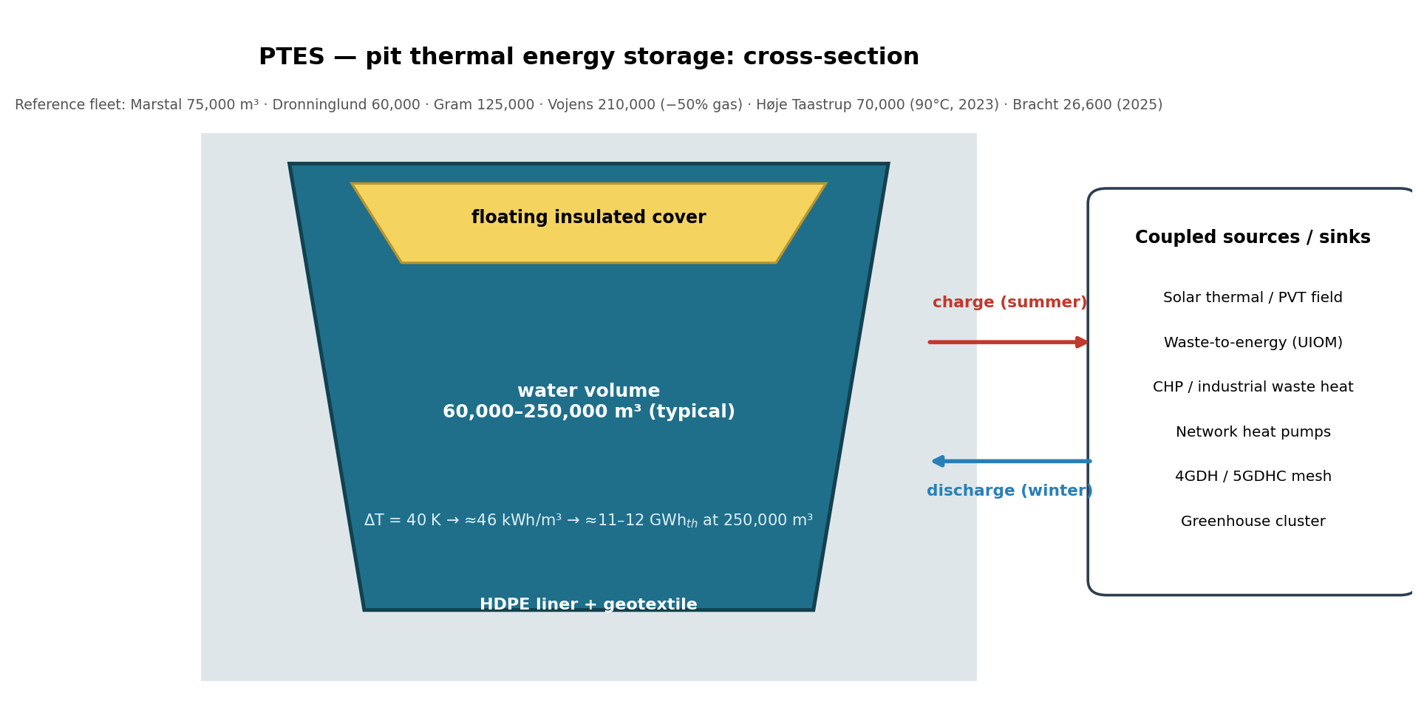
Figure 8. Cross-section of a pit thermal energy store (PTES): floating insulated cover, HDPE liner and geotextile, and the coupled sources and sinks that charge and discharge it through the year. Source: author’s schematic, sized on the European reference fleet in Table below and the 60,000–250,000 m³ typical range reported by the TREASURE project and Danish Energy Agency Technology Data (2024–25).
Site | Country | Volume (m³) | Commissioned | Note
Marstal (SUNSTORE) | DK | 75,000 | 2011–2012 | Solar + island network
Dronninglund | DK | 60,000 | 2013 | Efficiency reference case
Gram | DK | 125,000 | 2014–2015 | Solar + CHP
Vojens | DK | 210,000 | 2014–2015 | ‒50% gas consumption on the network
Toftlund | DK | 85,000 | 2016–2017 | —
Høje Taastrup | DK | 70,000 | 2023 | 90 °C, new-generation liner/cover
Lidzbark Warmiński | PL | 15,000 | 2023 | First Polish pit of this generation
Bracht | DE | 26,600 | 2025 | German extension of the fleet

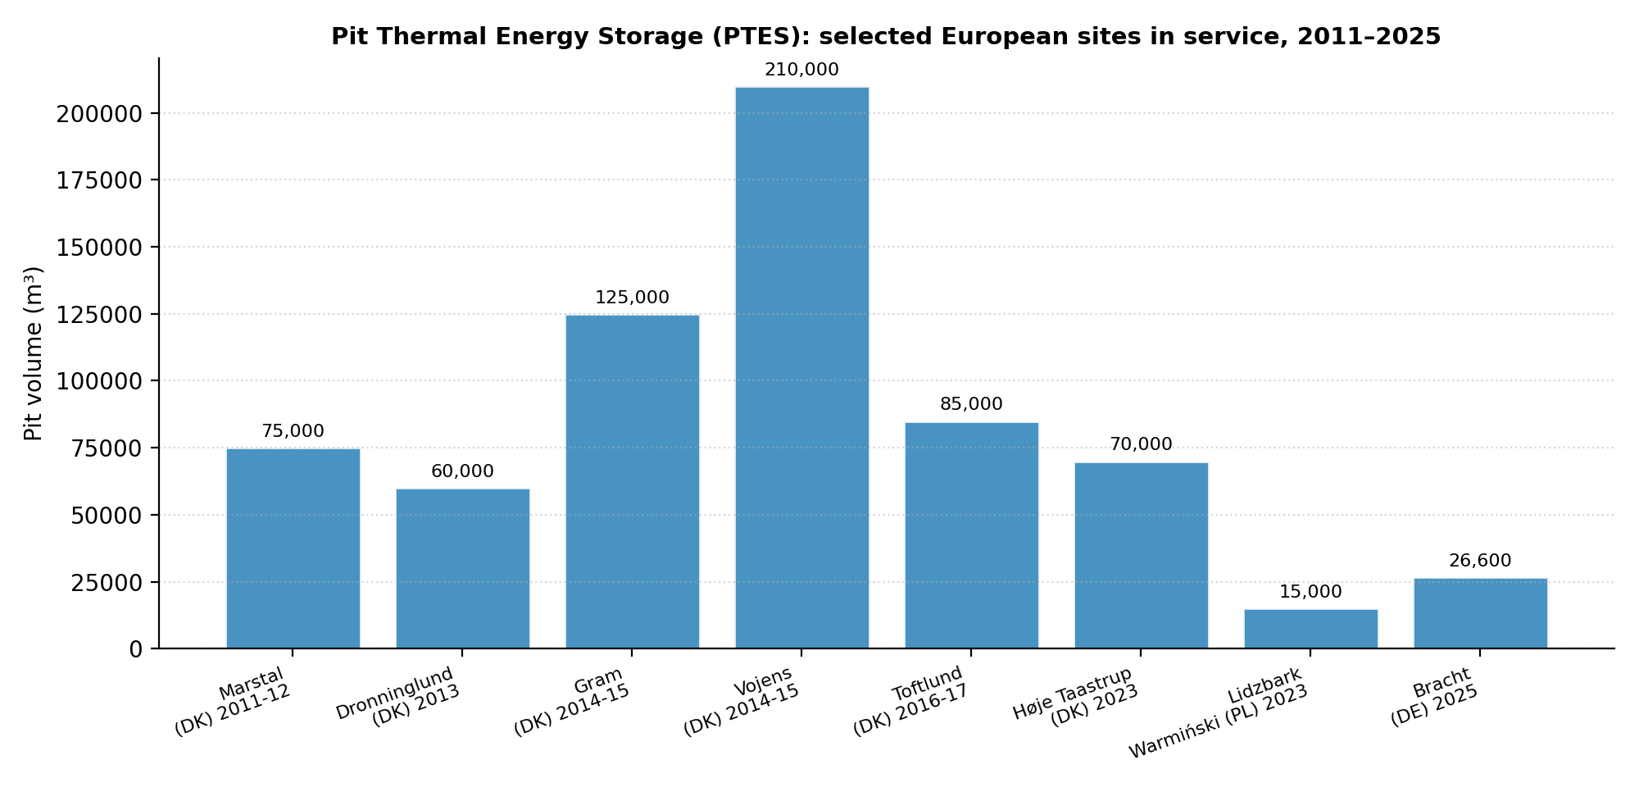
Figure 9. Pit Thermal Energy Storage: selected European sites in service, 2011–2025. Source: TREASURE project site inventory and Danish Energy Agency Technology Data (2024–25); see Annex A.
TREASURE (“Demonstrating Large Pit Thermal Energy Storages,” Grant 101136095) is coordinated by AEE INTEC (Austria), with 23 partners and €9.89 million of EU contribution over January 2024 to December 2027. It comprises seven demonstrators across five countries plus roughly fifteen satellite projects. Deliverable D2.1 sets out a site-selection and pre-feasibility method covering geotechnics, land availability, permitting, and performance indicators; deliverable D6.3, on non-market benefits, surveyed 2,873 citizens across Austria, Denmark, Germany, Poland and Sweden together with 48 network operators, finding that resilience, security of supply, and public acceptability justify extending a typical 15-year payback by roughly two years.
The 2050 target ranges from 2,000 pits (TREASURE roadmap) to approximately 8,100 pits of 250,000 m³ each to store 10% of European district-network heat. The cumulative potential cited is 35–110 TWhₑₕ, equivalent to 1–3 billion m³ of water at 60/90 °C. A 2050 European equilibrium model (Energy, 2026) shows that introducing 16.2 TWhₑₕ of PTES increases district heat-pump output by 46%, reduces biomass use by 51%, eliminates hydrogen boilers, and lowers total system cost by 1.3%.

2.4.2 ATES and BTES
More than 2,500 ATES systems are in operation worldwide, with the Netherlands representing a critical mass of that total. The HT-ATES system at Agriport Middenmeer stores roughly 440,000 m³ at approximately 87 °C, delivering approximately 20 GWhₑₕ/year to greenhouse clusters. At Koppert Cress, an ATES system at 150 m depth operates under the Green Deal 40 °C framework, serving greenhouses and neighbouring housing from the same energy stock. HEATSTORE and GEOTHERMICA have produced HT-ATES guidelines, Dutch greenhouse demonstrators, and a screening study for Île-de-France (Albian, Neocomian, Dogger aquifers).
On the borehole side, Emmaboda/Xylem in Sweden operates a 140-borehole field with a rapid payback after heat-pump integration; Darmstadt’s PUSH-IT project is the first medium-depth demonstrator (approximately 750 m); Beijing Daxing operates a field of roughly 11,000 boreholes; and the largest known European BTES, at roughly 1,000 boreholes, is a scientific infrastructure in Romania. In France, high-temperature ATES falls under a heavier authorisation regime than low-temperature ATES, so current practice remains mostly low-temperature; the Paris Basin, already equipped with more than fifty Dogger/Albian/Neocomian well doublets, is the natural bridge toward network-scale ATES and a Paris-region 5GDHC system.

2.4.3 Flooded mines (MTES) and 5GDHC
The Mine Water strand of the IEA Geothermal corpus is coordinated by the British Geological Survey with the UK Mining Remediation Authority. More than fifty sites are documented worldwide, totalling roughly 85 MWₑₕ of heating capacity and 20 MW of cooling capacity, with a clear shift from single-building to district-scale use. Heerlen’s Mijnwater system in the Netherlands is the reference 5GDHC case built on flooded mines, operating at ambient temperatures of 18–28 °C with COPs on the order of 4.5, serving mines, a data centre, a supermarket, and housing (already discussed in Part I). The Gateshead Heat Network in the United Kingdom is a mine-water extension of an urban network; the Baltic Centre, host of the Mine Water Symposium 2026, is heated by this network. Other documented sites include the Glasgow UK Geoenergy Observatory, Bochum Fraunhofer IEG, Freiberg (2023 demonstrator, 50–60% efficiency), and Springhill, Nova Scotia, commercial since 1998. The PUSH-IT and G2C projects (GEOTHERMICA, Scotland) route process waste heat into mines and then into district networks.

2.4.4 CTES and TTES
The CTES facility at Vantaa, Finland, of roughly 1.1 million m³ and up to 140 °C, is under construction as metropolitan-scale network storage. Lyckebo, Sweden — 115,000 m³ in service since 1983 — stands as proof of long service life for cavern storage. The Berlin-Forsthaus/Vattenfall TTES tank, approximately 56,000 m³ and 200 MWₑₕ, cycles 70–120 times per year, complementing seasonal storage with short- to medium-term buffering. In France, Newheat is progressing the first French PTES at Pau, sized at 10–30 GWhₑₕ, routing summer waste-incineration heat into the winter network through a partnership between Engie Solutions and the Banque des Territoires; Newheat is also developing a PTES + solar thermal + heat-pump configuration for greenhouses.

2.5 PVT Collectors and Water-Source Heat Pumps
Photovoltaic-thermal (PVT) hybrid collectors produce electricity and heat from the same square metre of roof or carport. Coupled to a water-source heat pump, they avoid both a borehole field and a noisy outdoor unit, making them a realistic retrofit option on dense existing building stock. IEA Solar Heating and Cooling (SHC) Task 60 is the international reference framework for PVT systems; the IEA SHC *Solar Heat Worldwide* series (2024 and 2025 editions) tracks market deployment.
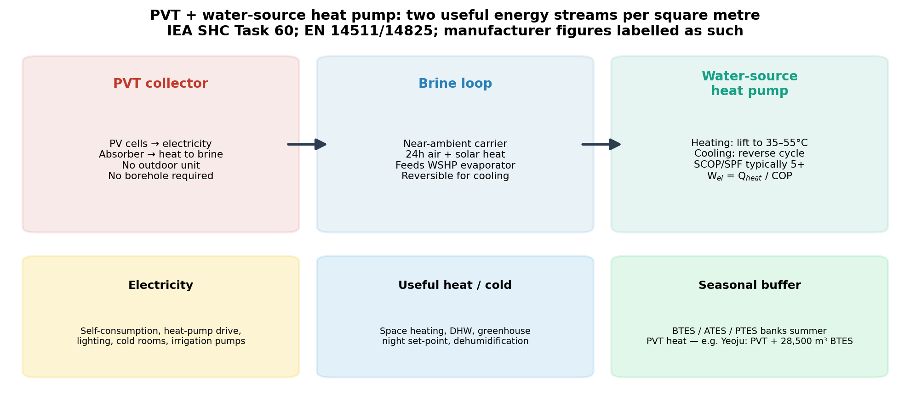
Figure 10. PVT collector plus water-source heat pump energy flows. Source: IEA SHC Task 60; Triple Solar published SPF up to 5.5 (2026, triplesolar.eu); DualSun SPRING4 announced SCOP up to 8.5 (dualsun.com); EN 14511/EN 14825 test-condition context. Manufacturer figures are labelled as such and should be read against climate and emitter temperature.

2.5.1 Why the hybrid matters
- Energy independence on European hardware — commercial PVT-plus-heat-pump packages are manufactured in the Netherlands, France and elsewhere.
- Electrical leverage — an SCOP of 5 or more means every electrical kilowatt-hour drawn yields roughly five thermal kilowatt-hours delivered.
- No drilling, no outdoor fan — deployable on existing dense urban fabric where a borehole field or an air-source outdoor unit is impractical.
- Land-use optimisation — two energy services from the same roof or carport area, a material advantage in cities and across greenhouse ranges.
- Climate resilience — continuous air exposure plus solar gain makes the evaporator source less brittle on cold peaks than a standalone air-to-water heat pump.
- Relevance for Africa — cooling duty (air conditioning, agricultural cold chain) and domestic hot water both benefit from high insolation, which maximises electrical and thermal yield simultaneously.

2.5.2 Verified and announced performance
Triple Solar (Netherlands) markets a PVT heat-pump package with SCOP/SPF up to 5.5 on published 2026 data. DualSun (France) publishes the SPRING collector family and a SPRING4 PVT-source heat-pump package with an announced SCOP up to 8.5. Both figures are manufacturer-published performance claims, distinct from independent measurement, and must be read against climate, emitter temperature, and the EN 14511/EN 14825 test standards under which they were generated; field installations, including Dutch deployments such as Ronduit Utrecht, provide operating evidence beyond datasheet values.

2.5.3 The stranded-summer-heat problem
PVT thermal output peaks in summer, precisely when buildings and greenhouses need it least. At Yeoju, South Korea, PVT collectors are coupled to a 28,500 m³ BTES — the direct link between PVT capture and UTES storage discussed in Section 2.3. USES4HEAT (Horizon Europe, coordinated by KTH, 2023–2027, approximately €9.7 million in grant funding) combines a PVT brick with high-temperature aquifer heat pumps and accelerated drilling. Without a seasonal store, summer PVT heat is stranded; without a meshed 4G/5G network, building clusters cannot share the surplus that does get captured — the same design logic set out for the three pillars in Part III.

2.5.4 Working-Fluid Selection and the Temperature-Dependent Efficiency Ceiling
“Water-source” describes the carrier loop that feeds the evaporator, not the refrigerant that circulates inside the heat pump’s compression cycle — and it is the refrigerant, not the carrier, that sets the achievable COP for a given lift. The IEA Heat Pump Technologies (HPT) TCP’s Annex 58 review of high-temperature heat pumps (HTHPs, delivery above 100 °C) identifies water itself (R718), ammonia (R717), carbon dioxide (R744), and hydrocarbons such as propane (R290) and butane (R600) as the natural refrigerants competing for this role, each with a different efficiency profile across the temperature range.
At the delivery temperatures relevant to the WSHPs discussed in Section 2.5 (roughly 35–55 °C, occasionally higher for booster duty), natural refrigerants other than water — ammonia, propane and other hydrocarbons, CO₂ — consistently deliver a better Carnot efficiency ratio (COP/COP_Carnot) than water as a refrigerant. Water only becomes the more efficient choice at substantially higher output temperatures: a direct simulation and prototype comparison by Wu et al. (2020) found that R718 (water) achieved the best system performance and Carnot efficiency of six refrigerants tested specifically for high-temperature heat pumps delivering above 100 °C, outperforming hydrocarbon and HFO alternatives at that range, at the cost of the much larger compressor swept volume and multi-stage compression that water’s low vapour density requires.
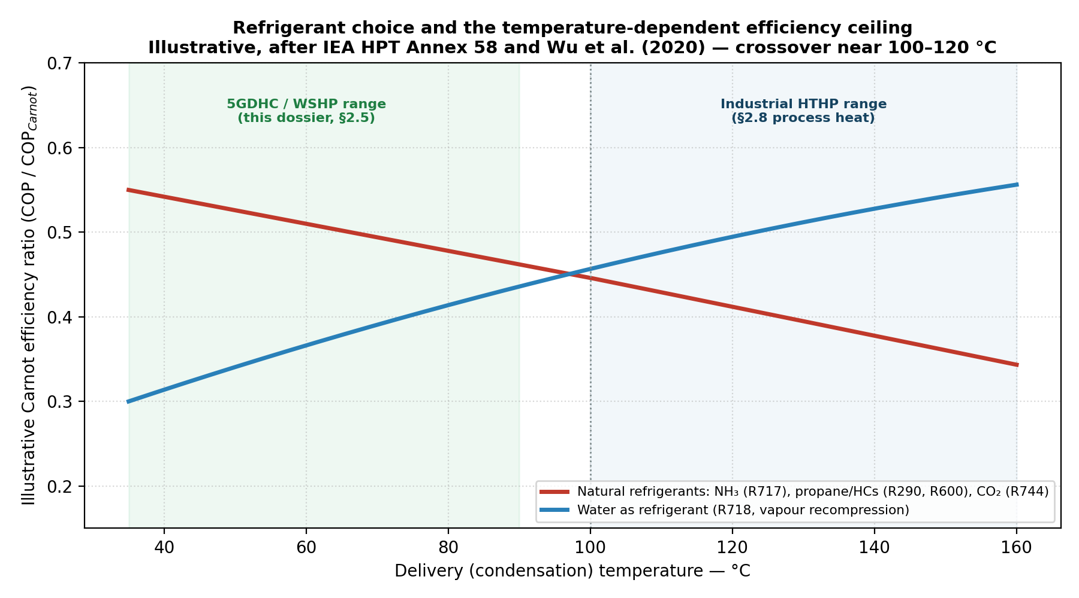
Figure 11. Illustrative Carnot efficiency ratio by refrigerant family as a function of delivery temperature. The qualitative crossover near 100–120 °C follows the direction of the findings in IEA HPT Annex 58 and Wu, D. et al. (2020), ‘The performance comparison of high temperature heat pump among R718 and other refrigerants,’ Renewable Energy, 154, 715–722; curves are schematic, not simulation output, and specific projects should be sized against manufacturer or Annex 58 performance data.
This crossover gives the 4GDH/5GDHC complementarity discussed in Section 1.3.1 a physical basis, not only a network-topology one. A 5GDHC ambient loop feeding building-level WSHPs at 35–55 °C is best served by ammonia, propane, or CO₂ heat pumps; a 4GDH backbone or an industrial process line requiring 90–150 °C output — the range discussed for waste heat and process cooling in Section 2.8 — increasingly favours water-vapour (R718) or ammonia/R718 cascade HTHPs, several of which are already commercially deployed per the IEA HPT Annex 58 project inventory. Specifying a single refrigerant family across an entire capture-store-distribute system, rather than matching it to each duty’s delivery temperature, leaves efficiency on the table at one end of the network or the other.

2.6 Buildings and 4G/5GDHC Networks: Linking Storage to the Grid
A fourth-generation network (50–70 °C) or a fifth-generation network (ambient, 5–35 °C, bidirectional, meshed — see Part I) only exits gas if it can shift thermal energy in time. Without seasonal storage, electric heat pumps draw on the power grid during cold hours, and summer solar and wind surpluses have no useful heat sink.
UTES is precisely that sink and that source. In a 5GDHC network, the store — ATES, BTES, mine, or engineered geostructure — is the balancing node of the mesh, into which every building, greenhouse, or process can inject or withdraw energy. Part I of this dossier established why a meshed architecture is decisive on flat terrain; this section adds the missing variable: the seasonal storage capacity, in GWhₑₕ, connected to that mesh.
The European regulatory framework already treats thermal storage as a matter of compliance as much as engineering. Under RED III Article 23, renewable energy in heating and cooling must rise by 1.1 percentage points per year; under Article 24, an indicative trajectory of +2.2 points per year applies to district heating and cooling networks. The Energy Efficiency Directive (EED) requires district networks to reach 50% renewable and/or waste heat by 2028, and zero grams CO₂/kWh by 2050, with transformation plans required. The Energy Performance of Buildings Directive (EPBD) is due for national transposition by May 2026. ETS2 applies to building heating from January 2028. Russian pipeline gas imports are due to end in September 2027.
The advocacy consequence follows directly: a kWhₑₕ stored in a pit, aquifer, or mine and returned in winter must be counted within these trajectories. If it is not, district networks remain accountably dependent on gas and biomass even when the energy is already present under the city.

2.7 Horticulture and Greenhouses
Protected-crop horticulture is an intensive electrical and thermal use case — night set-points, dehumidification, summer cooling, tempered irrigation — and one where thermal energy storage is already industrial practice rather than a demonstrator. At Agriport Middenmeer, HT-ATES at approximately 87 °C delivers approximately 20 GWhₑₕ/year at cluster scale; at Koppert Cress, a shared ATES system serving greenhouses and housing turns the energy stock into district infrastructure in its own right. At Adana, Turkey, ATES-served tomato greenhouses report a 70% reduction in energy cost and a 20% yield increase. Newheat is combining PTES, solar thermal, and heat pumps for roughly five hectares of greenhouses in France. At Yeoju, South Korea, a 28,500 m³ BTES is coupled to PVT collectors — the exact link to the companion PVT dossier: the PVT panels produce electricity and heat mostly in summer, and the BTES converts that surplus into winter energy. In Wallonia, ATES potential in alluvial and Cretaceous formations is documented but still little industrialised.
A simple sizing rule from Dutch practice: shared storage for greenhouses costs on the order of €0.5–6 per m² of greenhouse per year, depending on whether the service is heat only or heat plus cold. Cold is energy too: storing night-time or winter frigories avoids running chillers at full power during hot hours, reduces condensation and associated disease pressure, and stabilises the production calendar.

2.8 Industry, Waste Heat and Process Cooling
A large share of European industrial heat demand sits below 200 °C — within reach of UTES, high-temperature heat pumps, and district networks. Witter et al. note that 33% of U.S. industrial heat demand is below 100 °C and 44% falls between 100 and 500 °C; the European order of magnitude is comparable, meaning a majority share of process demand does not require an open flame.
The operating pattern is consistent across cases: capture thermal energy that has already been paid for — from waste incineration, paper mills, data centres, breweries, dairies, power-to-X plants, wastewater, or summer electricity surplus — store it, and return it to the process or the network when needed. USES4HEAT (Horizon Europe, coordinated by KTH, 2023–2027, approximately €9.7 million in grant funding) is developing an ATES at Riva del Garda on paper-mill waste heat (targeting roughly −10 GWh of methane per year and −2,000 tCO₂) and a BTES at Furuset, Oslo, drawing on incineration, data-centre, and wastewater heat for a low-temperature network, with Zagreb, Lom, Kozani, and Kvarnholmen as replication sites; enabling technologies include PVT, concentrating solar, high-temperature low-GWP ground-source heat pumps, accelerated drilling, 95 °C plastic collectors, and energy management systems. At Pau, Newheat is progressing waste-incineration heat through a PTES to the winter network, at 10–30 GWhₑₕ — the first French PTES to be developed as infrastructure rather than a comfort demonstrator.
Cold UTES is relevant for data centres and large commercial cooling: a large air-conditioning site can draw more than 90% of its annual cooling from an underground store in suitable climates, per a 2026 U.S. screening study covering seven building typologies across ten cities, with annual peak electricity demand reductions of roughly 38% in cooling-dominated cases. High-temperature storage technologies outside the UTES envelope — ceramic, slag, or molten-salt stores such as Kraftblock — cover the process segment beyond what low- and medium-temperature UTES can deliver; they complement rather than replace subsurface storage for buildings and greenhouses.

2.9 Africa: Mines, Greenhouses, Cascades, Post-Harvest Cooling
The IEA Geothermal corpus is Euro-Atlantic in its examples, but the underlying physics and engineering transfer directly. Africa is not a chapter of solidarity in this dossier; it is a deposit of use cases — greenhouses, drying, post-harvest cooling, agro-food processing, and mine reconversion — where thermal energy storage displaces diesel and fuel oil.

2.9.1 Geothermal cascades and greenhouses
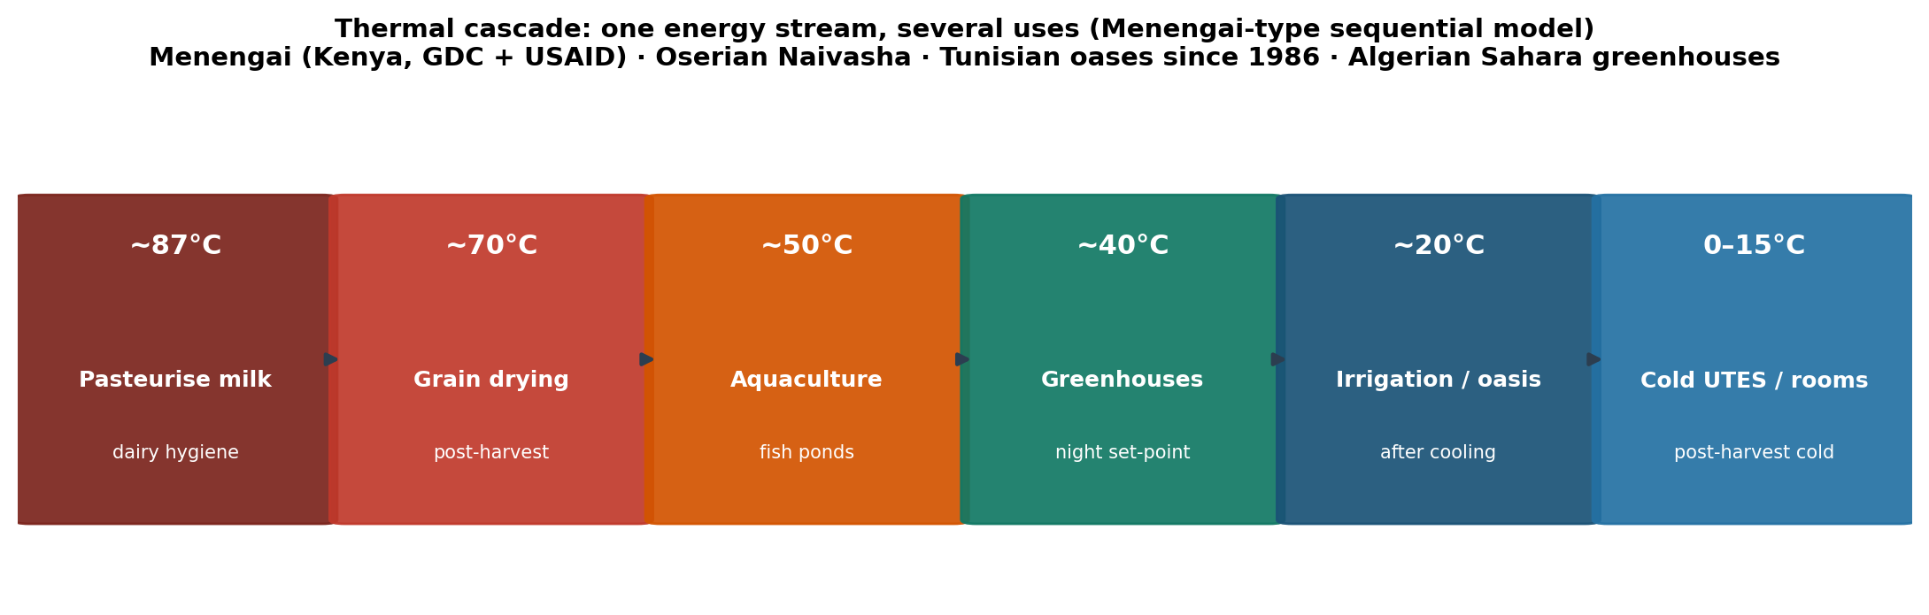
Figure 12. Thermal cascade: one geothermal energy stream serving several sequential uses, from milk pasteurisation at approximately 87 °C down to post-harvest cold storage at 0–15 °C. Source: author’s schematic based on the Menengai cascade (Kenya, GDC and USAID), with reference to Oserian Naivasha, Tunisian oasis geothermal systems in operation since 1986, and Algerian Sahara greenhouses.
In Kenya, Oserian (Naivasha) has used direct geothermal heat for export rose greenhouses since the early 2000s — a commercial proof, not a pilot. The Menengai cascade (GDC and USAID) uses water at approximately 87 °C in sequence: pasteurising milk, then drying grain, then heating fish ponds, then greenhouses — a single thermal energy source serving four uses, the model to replicate with a store (ATES/BTES) wherever geothermal flow is not continuous or where cooling is also required. In Tunisia, 473 farmers across 42 sites use water at 45–80 °C for both greenhouse heating and, after cooling, oasis irrigation — a unique desert-conditions case in operation since 1986. In Algeria’s Sahara, eighteen greenhouses (7,200 m²) operate at approximately 57 °C alongside fish farming at approximately 60 °C. In Egypt’s Bahariya oasis, air-earth heat exchangers keep greenhouses below 35 °C in summer and above 20 °C in winter.
Commonly cited order-of-magnitude direct-use potentials, to be verified country by country, include roughly 1–2 TWₑₕ for Kenya, 1.25–2.5 TWₑₕ for Tanzania and Ethiopia, and 3–6 TWₑₕ for Algeria. Eleven African countries already have a direct geothermal use in agriculture, health, or industry (IRENA’s 2022 guide to geothermal in agri-food value chains).

2.9.2 Flooded mines
In South Africa and Zambia’s Copperbelt, the volume of flooded mine galleries constitutes an already-excavated thermal energy store. The Agricola Model Mine project (Tshwane University of Technology, Pretoria) replicates the instrumentation used at Dannenbaum/Bochum. The Witwatersrand, Gauteng, and Free State basins represent infrastructure reconversion, not greenfield development — exactly the Mine Water narrative documented by IEA Geothermal.

2.9.3 Post-harvest cooling
The FAO estimates losses of up to 40% between field and market across several African supply chains. Cold is energy: solar-powered cold rooms (ColdHubs in Nigeria, Soko Fresh in Kenya) have already cut spoilage from roughly 50% to under 2%, with income gains of 20–50% per kilogram. Coupling these cold rooms to a Cold UTES system or an earth-air tunnel moves the model from daytime chiller operation to a stored-frigorie system. In hot climates, this line of work carries strategic priority comparable to European heating applications.

2.9.4 Upcoming events
The 11th African Rift Geothermal Conference (ARGeo C11) takes place in Moroni, Comoros, 19–24 October 2026 — the venue for advancing the thermal-storage agenda, not electricity alone, with energy and agriculture ministries.

2.10 Policy Framework and Advocacy Levers, 2026–2028
IEA ES TCP Task 45 states plainly that the design tools already exist and that interest has surged with the gas crisis, with projects planned in Denmark, Germany, the Netherlands, Poland, Austria, France, the Balkans, and China. What is missing is faster permitting, standards, bankability that recognises stored energy, and treatment of LTES as flexibility infrastructure in its own right.
# | Lever | Concrete objective
1 | Critical infrastructure status | Classify LTES as energy-flexibility infrastructure, on a par with gas storage. Euroheat & Power (June 2026) calls for European thermal storage to grow twentyfold by 2050.
2 | Unified permitting | One-stop permitting across water, mining, and planning law. RED III targets 12-month permitting in “renewable acceleration areas,” from which LTES is too often excluded (TREASURE Policy Brief 01, March 2026).
3 | RED III / EED / ETS2 accounting | Recognise stored-and-returned kWhₑₕ within heating-and-cooling trajectories; otherwise gas remains the unit of account.
4 | Bankability | Loan guarantees (BNG model: WACC 7% → 3.75%); risk guarantees on the Swiss Climate & Innovation Act model. TREASURE’s non-market benefits justify extending median 15-year payback by roughly two years.
5 | Heat procurement | Innovation Fund Heat Auction 2026, targeting 0.5→1.5 GWh commercial/industrial storage; integrate PTES/ATES/BTES into French district-heating calls (Fonds Chaleur, Banque des Territoires).
6 | Horizon Europe | Call CL5-2026-02-D3-22, dense urban UTES (€18M, €9M/project): ATES, CTES, BTES, engineered geostructures.
7 | EU–Africa mapping | Aquifers, mines, and quarries: BRGM, BGS, South African CGS, Maghreb geological surveys — the same logic as the BGS/Mining Remediation Authority corpus.
8 | Drilling skills transfer | Move oil-and-gas and deep-geothermal drilling capacity toward GeoTES, deep BTES, and MTES — an argument of sovereignty and employment.
9 | AppESS (Task 46) | Impose demand-side matching: which energy form, at what date, at what temperature — avoiding over- or under-sizing the storage vector for the use case.
10 | France | Clarify and streamline HT-ATES authorisation; progress Pau as the lead PTES case; connect the Paris Basin’s 50+ well doublets to seasonal storage and a meshed 5GDHC network.

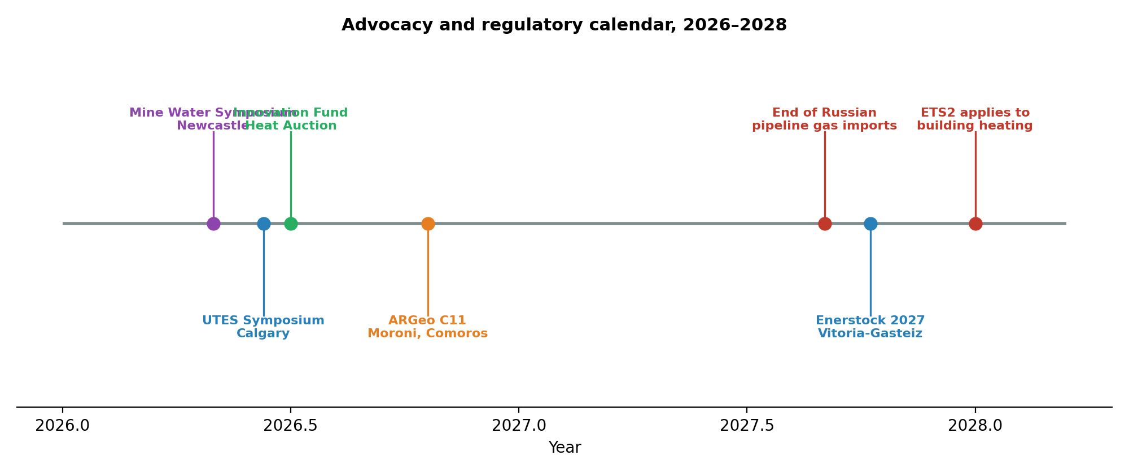
Figure 13. Advocacy and regulatory calendar, 2026–2028. Source: compiled from IEA ES TCP Task 45 event listings, TREASURE project communications, ARGeo C11 programme, and EU legislative calendar (RED III, EED, ETS2).

2.10.1 Task 45 contacts to engage
- Wim van Helden — AEE INTEC (Austria), LTES Task Manager and TREASURE coordinator.
- Geoffroy Gauthier — PlanEnergi (Denmark), sites and pits.
- Nathan Fournier — Newheat (France), first French PTES and greenhouse applications.
- Thomas Schmidt — Solites (Germany).
- Bijan Adl-Zarrabi — Chalmers (Sweden).
- Stephan Bolay (Switzerland) and Virginie Schmidlé-Bloch (AFPG, France) — IEA Geothermal Heating & Cooling Working Group.

Part III — Integration: Bridging District Heating and Thermal Storage

3.1 The Three Pillars: Capture, Store, Distribute
The district-heating history dossier (Part I) establishes the network: 5GDHC, exemplified by Heerlen and Paris-Saclay, is the distribution layer. The UTES dossier (Part II) establishes the reservoir: underground storage is what makes that network independent of gas in January. Without seasonal GWhₑₕ connected to the mesh, a thermodynamically efficient 5GDHC network still buys fossil thermies during cold hours.
Section 2.5 above sets out the capture side in more detail: PVT-plus-heat-pump systems deliver both electricity and heat per square metre of roof, year-round, at high seasonal COPs — but that heat output peaks precisely when the building or greenhouse needs it least. BTES, ATES, or PTES storage converts this summer surplus into winter energy. The Yeoju case (PVT + BTES) and the USES4HEAT project (PVT, ground-source heat pump, and accelerated drilling) are the two demonstrators to cite in any PVT advocacy note.
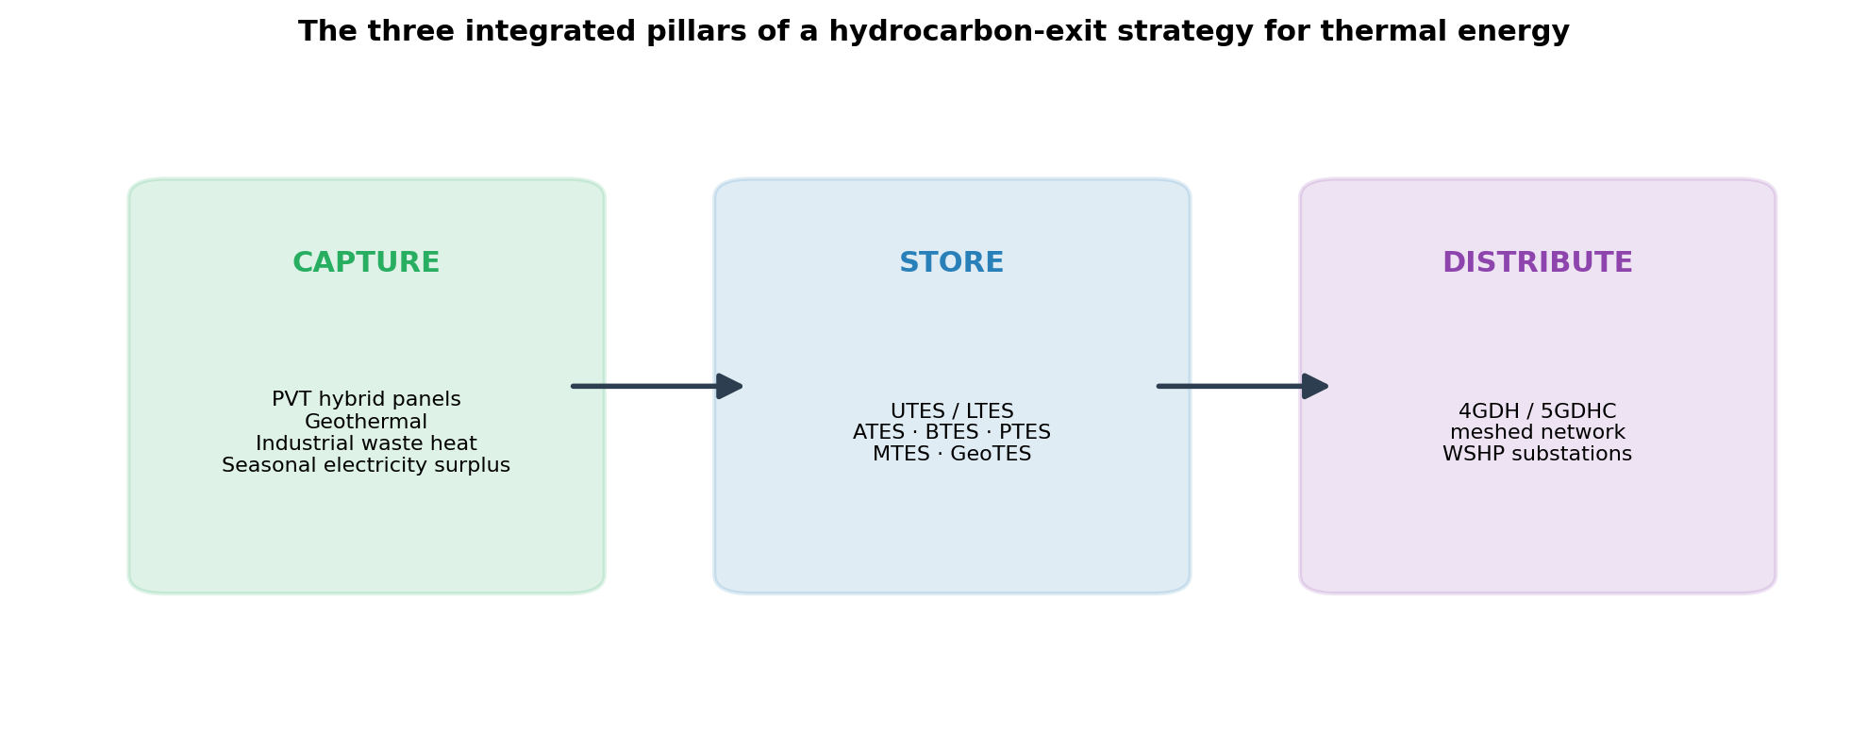
Figure 14. The three integrated pillars of a hydrocarbon-exit strategy for thermal energy: capture, store, distribute. Source: author’s synthesis of the district-heating history dossier and the UTES 2026 state-of-the-art dossier.
Read together, the three pillars — capture (PVT, geothermal, waste heat, electricity surplus), store (UTES/LTES), and distribute (a meshed 4GDH/5GDHC network) — form a single system. Remove the middle pillar, and the system reverts to burning gas on 15 January.

3.2 Operational Roadmap

Within 90 days
- Progress Pau/Newheat as the lead French PTES project (land, water permit, waste-incinerator supply contract, Banque des Territoires financing).
- Request AFPG and BRGM to screen ATES/BTES/mine-water potential across the Paris Basin and French mining basins (Nord, Lorraine, Provence) using the BGS methodology.
- Add a “seasonal GWhₑₕ” line to every open Fonds Chaleur or district-network dossier.
- Prepare a contribution to ARGeo C11 (Comoros, October 2026) covering the Menengai cascade, Maghreb greenhouses, and southern African flooded mines.

Within 12 months
- Secure a pilot PTES or HT-ATES permit in France with a 12-month target timeline.
- Pair PVT with BTES/ATES on a greenhouse cluster, replicating Yeoju or Middenmeer, in France or the Maghreb.
- Brief the French Directorate-General for Energy and Climate on accounting for stored kWhₑₕ within RED III and EED trajectories.
- Produce a joint IEA Geothermal / CGS / BRGM mapping of flooded mines across the EU, North Africa, and Southern Africa.

Toward Enerstock 2027
- Present a Franco-African UTES project (greenhouses plus mine or aquifer) at Vitoria-Gasteiz with a closed economic model, not a literature review.
- Have a French PTES or HT-ATES project in the ground, or at minimum in public-inquiry notification, by the time of the congress.

Conclusions and Outlook
District heating has progressed from the high-temperature steam systems of the late nineteenth century to the low-exergy, bidirectional 5GDHC networks now under development. Each generation has been defined by progressive reductions in temperature, improvements in materials and control, and broader integration of diverse energy sources. Thermodynamically, the move toward ambient temperatures maximises heat-pump COP, minimises irreversible losses, and enables the valorisation of low-grade heat that would otherwise be discarded. Hydraulically, the corresponding move toward meshed topologies is equally necessary if these thermodynamic gains are to be fully captured in real networks, particularly on flat terrain and in systems serving large numbers of prosumers and distributed sources.
Underground thermal energy storage is the mechanism that lets these networks decouple from gas across the calendar year. The 2026 IEA Geothermal corpus, together with Task 45, Task 46, GEOTHERMICA, HEATSTORE and TREASURE, establishes that PTES, ATES, BTES, MTES, CTES, TTES and GeoTES are mature, costed, and already deployed at meaningful scale in Northern Europe, with a clear industrialisation pathway to 2050. The remaining obstacles are not primarily technological: they are permitting timelines, bankability frameworks, and regulatory accounting under RED III, the EED, and ETS2.
For Europe, the priority is to industrialise PTES and ATES at the pace TREASURE and Task 45 describe, and to connect that storage capacity to meshed 4G/5GDHC networks rather than treating either investment in isolation. For Africa, the priority is to recognise that geothermal cascades, flooded mines, and post-harvest cold chains are not a lesser echo of the European case but a distinct and already-proven deposit of applications, where thermal storage displaces diesel and fuel oil rather than pipeline gas. The state of the art of useful heating-and-cooling storage is the subsurface: pit, aquifer, borehole, mine, reservoir. The unit of account is the thermal kilowatt-hour. What remains is to classify this physics as infrastructure, count it within RED III and the EED, finance it as gas storage has been financed, and deploy it from the Paris Basin to the East African Rift.

Annex A — Consolidated Reference List
References are grouped by source dossier and reproduced with the URLs given in the originating documents.

A.1 District heating, 4GDH and 5GDHC
- Lund, H., Werner, S., Wiltshire, R., Svendsen, S., Thorsen, J.E., Hvelplund, F. & Mathiesen, B.V. (2014). ‘4th Generation District Heating (4GDH): Integrating smart thermal grids into future sustainable energy systems.’ Energy, 68, 1–11. https://doi.org/10.1016/j.energy.2014.02.089
- Buffa, S., Cozzini, M., D’Antoni, M., Baratieri, M. & Fedrizzi, R. (2019). ‘5th generation district heating and cooling systems: A review of existing cases in Europe.’ Renewable and Sustainable Energy Reviews, 104, 504–522. https://doi.org/10.1016/j.rser.2018.12.059
- Lund, H., Østergaard, P.A., Nielsen, T.B., Werner, S., Thorsen, J.E., Gudmundsson, O., Arabkoohsar, A. & Mathiesen, B.V. (2021). ‘Perspectives on fourth and fifth generation district heating.’ Energy, 227, 120520. https://doi.org/10.1016/j.energy.2021.120520 (open access; establishes that 5GDHC is a parallel, complementary development, not a sequential successor, to 4GDH — see Section 1.3.1).
- Werner, S. (2017). ‘International review of district heating and cooling.’ Energy, 137, 617–631. https://doi.org/10.1016/j.energy.2017.04.045
- Danish Board of District Heating (DBDH). District Heating History. https://dbdh.org/district-heating-history/
- Danfoss. District heating generations explained. https://www.danfoss.com/en/about-danfoss/articles/dhs/district-energy-generations-explained/
- IEA District Heating and Cooling (IEA DHC) programme publications and Annex reports (various years) on low-temperature district heating.
- Technical literature on district heating network topologies (radial, looped, meshed) and hydraulic design of bidirectional low-temperature systems: Euroheat & Power; DHC+ Technology Platform; D2Grids project reports; related academic work.

A.2 UTES / LTES state of the art
- IEA Geothermal, LinkedIn post, September 2026, UTES / Mine Water / LTES corpus (entry point for Part II of this dossier).
- Witter, E., Akindipe, D., Zhu, G., McTigue, J. (2026). ‘Geological thermal energy storage offers terawatt-hours of energy storage capacity.’ npj Thermal Science and Engineering. doi:10.1038/s44435-026-00008-3
- IEA Energy Storage TCP, Task 45, Large Thermal Energy Storage — https://iea-es.org/task-45 — van Helden, Gauthier, Fournier, Schmidt, Adl-Zarrabi.
- IEA Energy Storage TCP, Task 46, Application-Oriented Energy Storage Selection (AppESS) — https://iea-es.org/task-46
- TREASURE, Grant 101136095, treasure-project.eu; Deliverable D2.1, site selection (Zenodo, 2025); Deliverable D6.3, non-market benefits; Policy Brief 01 (March 2026).
- Danish Energy Agency, Technology Data for Energy Storage / Heating, 2024–2025 update (PTES efficiencies 80/90/95%, CAPEX revision).
- GEOTHERMICA / HEATSTORE — HT-ATES guidelines, European UTES workshops, 2024–2026.
- IEA Geothermal, Mine Water Energy Expert Group (British Geological Survey) — case studies: Gateshead, Lanchester Wines, Glasgow UKGEOS, Bochum, Heerlen.
- IEA Geothermal Working Group on Heating & Cooling — S. Bolay, V. Schmidlé-Bloch (AFPG).
- USES4HEAT (KTH) — ATES Riva del Garda, BTES Furuset.
- Energy (2026). ‘Flexibility through thermal energy storage: cost-effective electrification of European district heating networks.’ (+46% heat-pump output, −51% biomass, −1.3% system cost).
- IRENA (2022). Geothermal in the agri-food value chain.
- World Bank / International Geothermal Association (IGA) — direct-use case studies, Africa (Kenya, Tunisia, Algeria, Malawi).
- ARGeo C11, Moroni, Comoros, 19–24 October 2026.
- Enerstock 2027, CIC energiGUNE, Vitoria-Gasteiz, 6–8 October 2027.
- Companion project dossiers (source lineage): District_Heating_Networks_History_5GDHC_Dossier_Updated; Solutions_Chauffage_Refroidissement_PVT_Europe_Afrique_2026 (PVT source dossier; its content reached this revision via a parallel AI-compiled edition of the same three project dossiers, cross-checked against the citations below — see Revision History).

A.3 PVT collectors, heat pumps and refrigerants
- IEA Solar Heating and Cooling (SHC) Programme, Task 60 — PVT Systems. https://task60.iea-shc.org/
- IEA SHC. Solar Heat Worldwide, 2024 and 2025 editions.
- Solar Heat Europe — market reports and hybrid-solar position papers. https://solarheateurope.eu/
- Triple Solar. PVT Heat Pump. Published SPF/SCOP data, 2026. https://triplesolar.eu/en/pvt-heat-pump/ (manufacturer figure).
- DualSun. SPRING collector and SPRING4 PVT-source heat pump, announced SCOP up to 8.5. https://dualsun.com/en/products/dualsun-spring/ ; https://dualsun.com/en/solutions/pvt-source-heat-pump/ (manufacturer figures).
- EN 14511 and EN 14825 — heat-pump COP and SCOP/SEER test methods.
- IEA Heat Pump Technologies (HPT) TCP, Annex 58 — High-Temperature Heat Pumps, Task 1 technology report. heatpumpingtechnologies.org/annex58 (refrigerant selection: R718/R717/R744/hydrocarbons across the temperature range — see Section 2.5.4).
- Wu, D., Hu, B., Wang, R.Z., Fan, H.B. & Wang, R.J. (2020). ‘The performance comparison of high temperature heat pump among R718 and other refrigerants.’ Renewable Energy, 154, 715–722. https://doi.org/10.1016/j.renene.2020.03.034

A.4 Regulatory instruments cited
- Directive (EU) 2023/2413 (RED III) — Articles 23 and 24, renewable energy trajectories for heating and cooling and for district networks.
- Directive (EU) 2023/1791 (Energy Efficiency Directive, recast — EED) — renewable/waste-heat share requirements for district networks, transformation plans.
- Directive (EU) 2024/1275 (Energy Performance of Buildings Directive, recast — EPBD) — national transposition deadline May 2026.
- EU Emissions Trading System 2 (ETS2), buildings and road transport — applies to building heating from January 2028.
- EN 14511 / EN 14825 — heat pump testing and rating standards referenced for COP/SCOP/SEER context.

Annex B — Acronyms
Acronym | Definition
1GDH–5GDHC | First- to fifth-generation district heating (and cooling) systems
AFPG | Association Française des Professionnels de la Géothermie
AppESS | Application-oriented Energy Storage Selection (IEA ES TCP Task 46)
ATES | Aquifer Thermal Energy Storage
BGS | British Geological Survey
BRGM | Bureau de Recherches Géologiques et Minières (France)
BTES | Borehole Thermal Energy Storage
CAPEX | Capital Expenditure
CHP | Combined Heat and Power
COP | Coefficient of Performance
SCOP | Seasonal Coefficient of Performance
CTES | Cavern Thermal Energy Storage
DEA | Danish Energy Agency
DH / DHC | District Heating / District Heating and Cooling
EED | Energy Efficiency Directive (EU)
EPBD | Energy Performance of Buildings Directive (EU)
ETS2 | EU Emissions Trading System 2 (buildings and road transport)
GeoTES | Geological (deep formation) Thermal Energy Storage
GWhₑₕ / TWhₑₕ | Gigawatt-hour / Terawatt-hour, thermal
HTHP | High-Temperature Heat Pump (delivery above 100 °C)
IEA | International Energy Agency
IEA ES TCP | IEA Energy Storage Technology Collaboration Programme
IGA | International Geothermal Association
IRENA | International Renewable Energy Agency
kWhₑₕ | Kilowatt-hour, thermal
LTES | Large Thermal Energy Storage
MTES | Mine (Water) Thermal Energy Storage
MVR | Mechanical Vapour Recompression
PTES | Pit Thermal Energy Storage
PVT | Photovoltaic-Thermal (hybrid solar collector)
RED III | Renewable Energy Directive III (EU, Directive 2023/2413)
RES | Renewable Energy Sources
RTES | Reservoir Thermal Energy Storage
SEER | Seasonal Energy Efficiency Ratio
SPF | Seasonal Performance Factor
TREASURE | Demonstrating Large Pit Thermal Energy Storages (Horizon Europe project, Grant 101136095)
TRL | Technology Readiness Level
TTES | Tank Thermal Energy Storage
UIOM | Unité d’Incinération d’Ordures Ménagères (municipal solid-waste incineration/waste-to-energy)
UTES | Underground Thermal Energy Storage
WACC | Weighted Average Cost of Capital
WSHP | Water Source Heat Pump

Index
Revision History 2
Executive Summary 3
Part I — History of Urban District Heating Networks and 5GDHC 4
1.1 Historical Origins and Early Developments 4
1.2 The Four Generations of District Heating (1GDH–4GDH) 5
1GDH — approximately 1880–1930 5
2GDH — approximately 1930–1980 5
3GDH — approximately 1980–2020 (“Scandinavian” technology) 5
4GDH — emerging from approximately 2020 5
1.3 Fifth-Generation District Heating and Cooling (5GDHC) 5
1.3.1 4GDH and 5GDHC: Parallel, Not Sequential, Generations 6
1.4 Network Topologies and the Strategic Importance of Meshing 7
Why meshing becomes decisive in low-temperature and flat-terrain systems 7
1.5 Thermodynamic Foundations and Governing Equations 8
Heat transport and energy balance 8
Distribution heat losses 8
Heat-pump performance 8
Exergy considerations 8
Hydraulic losses 9
1.6 Global Status, Benefits and Challenges 9
Part II — Underground Thermal Energy Storage (UTES): State of the Art 2026 10
2.1 The IEA Geothermal 2026 Corpus 10
2.2 Useful Physics: Storing Thermal Energy 10
2.3 UTES Taxonomy 2026 11
2.3.1 GeoTES: the deep-formation complement (Witter et al., 2026) 12
2.4 European Industrial Evidence 13
2.4.1 PTES — the European fleet and the TREASURE industrialisation programme 13
2.4.2 ATES and BTES 14
2.4.3 Flooded mines (MTES) and 5GDHC 14
2.4.4 CTES and TTES 15
2.5 PVT Collectors and Water-Source Heat Pumps 15
2.5.1 Why the hybrid matters 15
2.5.2 Verified and announced performance 16
2.5.3 The stranded-summer-heat problem 16
2.5.4 Working-Fluid Selection and the Temperature-Dependent Efficiency Ceiling 16
2.6 Buildings and 4G/5GDHC Networks: Linking Storage to the Grid 17
2.7 Horticulture and Greenhouses 18
2.8 Industry, Waste Heat and Process Cooling 18
2.9 Africa: Mines, Greenhouses, Cascades, Post-Harvest Cooling 19
2.9.1 Geothermal cascades and greenhouses 19
2.9.2 Flooded mines 19
2.9.3 Post-harvest cooling 19
2.9.4 Upcoming events 20
2.10 Policy Framework and Advocacy Levers, 2026–2028 20
2.10.1 Task 45 contacts to engage 21
Part III — Integration: Bridging District Heating and Thermal Storage 22
3.1 The Three Pillars: Capture, Store, Distribute 22
3.2 Operational Roadmap 22
Within 90 days 22
Within 12 months 22
Toward Enerstock 2027 23
Conclusions and Outlook 23
Annex A — Consolidated Reference List 24
A.1 District heating, 4GDH and 5GDHC 24
A.2 UTES / LTES state of the art 24
A.3 PVT collectors, heat pumps and refrigerants 25
A.4 Regulatory instruments cited 25
Annex B — Acronyms 26
Index 28

