Document ID: EE-PUB-ERM-001
Revision: 02C
Date: August 6, 2026
Keywords: industrial reliability, commercial aviation, CS-25, human spaceflight, transport safety, risk management, independent certification

EngEthics Consulting
Public initiation study
The Scale of Controlled Risk
Understanding why some highly complex technologies are extremely safe, and others are not
Study led by Francois Dorleans (EngEthics Consulting), with AI-assisted research and drafting

What this document explains:
- Why the danger level of a technology does not primarily depend on its complexity, but on how its risk is governed.
- How two highly demanding fields, civil aviation and human spaceflight, achieve radically different safety outcomes.
- How to place any activity, technical or not, on a shared reading scale, from the pedestrian to the rocket.

1. A reflex worth correcting: complexity does not mean danger
Public debate often equates technological complexity with danger: the more sophisticated a system, the more frightening it seems. This intuition is misleading. A modern airliner contains millions of parts, and yet remains, statistically, one of the safest means of transport ever devised. Conversely, a simple, age-old activity such as cycling shows, kilometre for kilometre, a markedly higher risk of death than driving a car.
What actually determines the safety level of an activity is not its complexity as such, but the maturity of the system that governs its risk: design with safety margins, independent testing, third-party certification, mandatory incident reporting, and systematic correction after every failure. It is this combination, complexity on one side and rigor of control on the other, that makes it possible to build a shared reading scale, applicable to any activity that carries risk: walking, cycling, driving, rail, aviation, or any other technical field, present or future.

2. The pinnacle of industrial control: civil aviation
The European CS-25 standard, issued by the European Union Aviation Safety Agency (EASA), governs the design of large aircraft above 5,700 kg maximum take-off weight. This reference document, running past 1,300 pages, requires that any failure capable of causing the loss of the aircraft have a probability below one in a billion per flight hour, for an aircraft flying continuously, an event expected less than once every 100,000 years. Compliance with this requirement is not self-declared by the manufacturer: it is independently verified by the certifying authority, whose own test pilots take part in the validation flights before any aircraft enters service.
Statistics confirm this level of control. According to the International Air Transport Association (IATA), commercial aviation worldwide recorded, in 2024, one accident per 880,000 flights out of a total of 40.6 million flights, a rate slightly better than the average of the previous five years.
According to IATA, commercial aviation recorded one accident per 880,000 flights in 2024 out of 40.6 million flights operated, a rate below the five-year average.
This outcome is not a matter of chance: it is the direct product of a three-pillar system, design with extreme safety margins, mandatory independent certification, and exhaustive feedback after every incident, however minor.

3. A revealing counter-example: human spaceflight
Human spaceflight involves engineering at least as demanding as aviation, carried out by top-tier agencies and industrial contractors. And yet, its safety record remains, to this day, far worse than that of civil aviation: of the roughly 791 people who have flown into space since 1961, 19 have died during a flight or a directly related incident, a statistical fatality rate of about 2.4%.
Since the beginning of human spaceflight, roughly 791 people have flown into space and 19 of them have died, which sets the statistical fatality rate at close to 2.4%.
This gap is not explained by any lack of rigor among space engineers, but by two structural realities that the risk scale helps to make visible:
- The environment is intrinsically more hostile: extreme accelerations, vacuum, radiation, atmospheric re-entry, physical constraints with no equivalent in aviation, which leave far smaller safety margins.
- The fleet is tiny: a few hundred crewed flights in sixty years, against 40 million aviation flights in a single year. A system can only learn from its failures, and thus converge toward extreme reliability, through a considerable number of trial-and-correction cycles.
Human spaceflight has nonetheless improved markedly as experience has accumulated: no fatality has been recorded on a crewed flight since 2003.
No astronaut fatality has been reported in human spaceflight since 2003.
The lesson to draw is this: two fields that are comparable in engineering demands can display radically different safety levels, depending on the maturity of their feedback loop and the extent to which risk has been disciplined by decades of independent certification and systematic correction.

4. Building the scale: two axes, not one
To compare activities as different as walking, cycling, driving, rail, aviation, and spaceflight, two axes of reading are needed, not one:
- Technological complexity and energy involved, from walking (practically none) to orbital launch (extreme).
- The rigor of independent risk oversight, that is, whether or not a mandatory third-party certification exists, together with a systematic feedback process and an oversight authority with real enforcement power.
An activity is not safe or dangerous in absolute terms: it occupies a position on these two axes. Commercial aviation sits at the top right, high energy involved, mature independent control. Human spaceflight sits far to the right, but lower, high energy, still-maturing control. Walking and cycling sit at the bottom left, low energy, but also little or no independent control, since the risk is managed individually by each user.
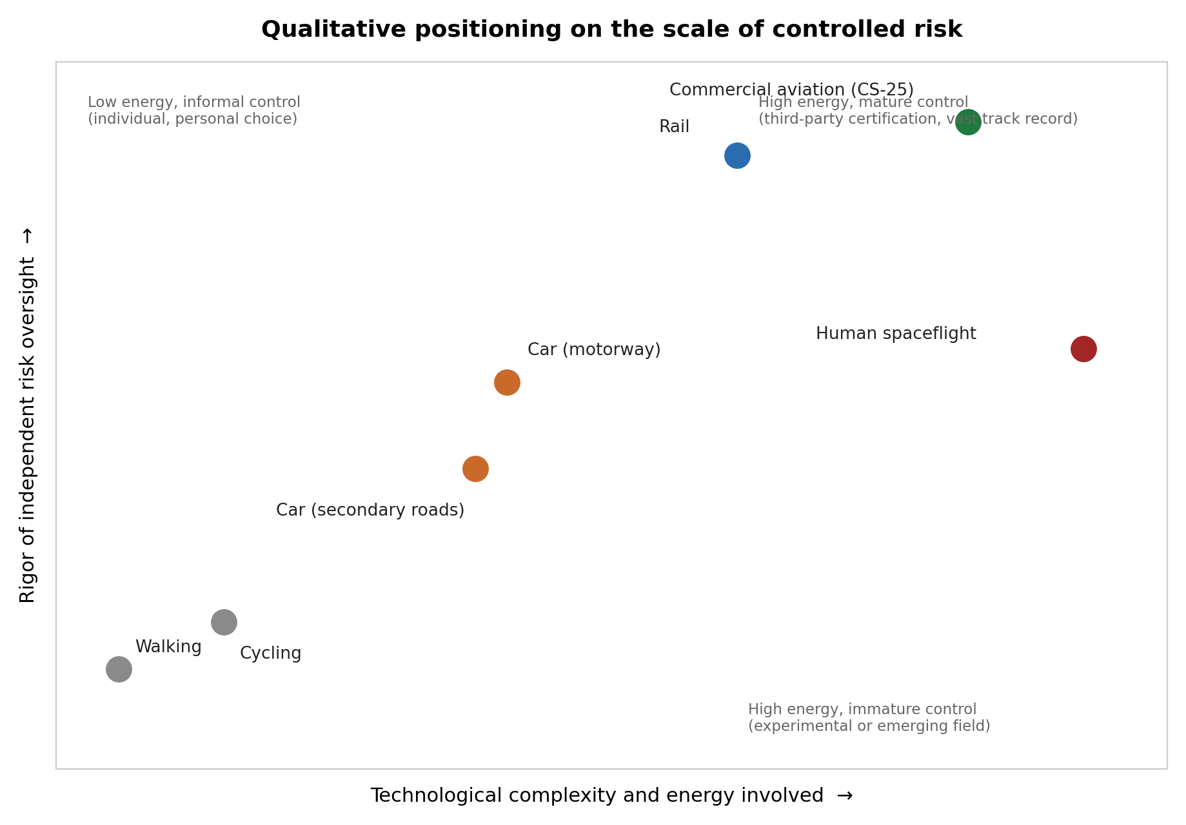
This positioning is qualitative, an exercise in public explanation rather than a precise measurement, but it immediately reveals what raw figures often obscure: it is not the position on the horizontal axis (complexity) that determines safety, it is the position on the vertical axis (rigor of control).

5. The numbers, with their units, because the unit changes everything
The same mode of transport can appear either very safe or very risky depending on the unit chosen: per kilometre travelled, per hour of exposure, or per trip taken. This is a frequent source of confusion in public debate, and one worth defusing from the outset.
Mode / activity | Unit | Measured risk | Source
Rail (Switzerland) | per billion pax-km | ~1 death / 194 billion pax-km | OFS, 2014-2023
Car (motorway, France) | per billion veh.-km | ~5.4 deaths / billion km | Road safety
Car (all roads, France) | per billion km | ~6 deaths / billion km | K indicator
Cycling | relative risk / km | ~3x the risk of driving | ONISR
Commercial aviation (world) | per flight | 1 accident / 880,000 flights (2024) | IATA 2025
Human spaceflight | per person flown | ~2.4% statistical fatality rate (19/791) | 1961-2026 history
Rail stands out as the safest mode per kilometre travelled, with one death per 194 billion passenger-kilometres on average over the past decade in Switzerland.
Over the period 2014-2023, an average of one death was recorded per 194 billion passenger-kilometres travelled by rail.
Cycling, by contrast, shows a death risk per kilometre roughly three times higher than driving, with the large majority of fatal cycling accidents resulting from a collision with a motor vehicle.
The risk of being killed while cycling is roughly three times higher than for a car driver, with most cycling deaths occurring when a motor vehicle strikes the cyclist.
Human spaceflight best illustrates this unit trap: measured per kilometre travelled, it looks safe, since each mission covers enormous distances in orbit; measured per mission or per person, its risk remains far higher than any other mode presented here. The right question is therefore never is this mode safe, but safe, measured how, and for whom.

6. One last clarification: risk is not only human
An industrial risk-management framework generally distinguishes four dimensions, often summarized by the acronym PARE: People, Assets, Reputation, and Environment. The scale presented here has focused on risk to people, the most intuitive dimension and the best documented statistically, but the same event, an industrial failure or a transport accident, can rank very differently depending on which dimension is examined. An accident with no human casualties at all can, for instance, represent a major reputational or environmental risk.
This four-dimension grid is not specific to one sector: it applies just as well to a drilling site, a power plant, a transport network, or any emerging technology. It is a generic reading tool, of which aviation and spaceflight are here only two possible illustrations among others, on the same footing as cars, trains, bicycles, or walking.

7. Key takeaways
- Technological complexity, on its own, says nothing about an activity's actual level of danger.
- What makes a technology safe is the maturity of its risk-control system: independent certification, exhaustive feedback, systematic correction.
- Civil aviation is today the most accomplished example of this control; human spaceflight, though just as demanding in engineering terms, remains in a phase where the feedback loop is still statistically limited.
- Any risk comparison must state its unit of measurement (per kilometre, per hour, per trip, per person): changing the unit can reverse the ranking.
- This two-axis scale, complexity and rigor of control, makes it possible to place any activity or technology, current or emerging, on a single, shared public reading grid.

Reference List
• IATA, 2024 Safety Report (press release, February 26, 2025): 2024 commercial aviation accident and flight-volume rates. https://www.iata.org/contentassets/1b6a19c8edec4ef9b329d62fc2a9a9f3/2025-02-26-01-fr.pdf
• Franceinfo, Les accidents d'avion ont baisse en 2024, mais pas le nombre de morts, February 26, 2025. https://www.franceinfo.fr/economie/aeronautique/les-accidents-d-avions-ont-baisse-en-2024-mais-pas-le-nombre-de-morts_7097661.html
• Wikipedia, List of spaceflight-related accidents and incidents, updated April 2026: number of people who have flown to space and statistical fatality rate. https://en.wikipedia.org/wiki/List_of_spaceflight-related_accidents_and_incidents
• MDPI Aerospace, Sixty Years of Manned Spaceflight, Incidents and Accidents Involving Astronauts between Launch and Landing, 2022: no fatalities in crewed flight since 2003. https://www.mdpi.com/2226-4310/9/11/675
• Swiss Federal Statistical Office (OFS), Accidents des transports: deaths per billion passenger-kilometres by transport mode, 2014-2023. https://www.bfs.admin.ch/bfs/fr/home/statistiques/mobilite-transports/accidents-impact-environnement/accidents-transports.html
• French National Road Safety Observatory (ONISR), Accidentalite a velo et exposition au risque: relative risk for cyclists, drivers, and pedestrians. https://www.onisr.securite-routiere.gouv.fr/en/node/234
• Slate.fr, La verite sur la mortalite routiere: fatality rate on French motorways per billion kilometres travelled. https://www.slate.fr/story/104231/mortalite-routiere-accident-verite
• Securite routiere (K indicator), Vocabulaire, mortalite au milliard de kilometres parcourus. http://www.securite-routiere.org/Connaitre/vocabulaire/k.htm

Acronym Definitions
CS-25: Certification Specifications 25, the airworthiness standard for large aircraft (maximum take-off weight above 5,700 kg), issued by EASA.
EASA: European Union Aviation Safety Agency.
IATA: International Air Transport Association.
MDPI: Multidisciplinary Digital Publishing Institute, an open-access scientific publisher.
OFS: Office federal de la statistique, the Swiss Federal Statistical Office.
ONISR: Observatoire national interministeriel de la securite routiere, the French National Road Safety Observatory.
PARE: People, Assets, Reputation, Environment, a four-dimension framework for industrial risk management.
EngEthics Consulting. Study led by F. Dorleans, with AI support. Educational, non-technical document.

